
DATASTRUCTURES AND ALGORITHMS 23CSE203 LAB MANUAL
SUBMITTED BY
NAME | K.GAYATHRI REDDY
ROLL NO | AV.SC.U4CSE25120
YEAR/SEM/SECTION | 2ndYEAR/ SEM-3/CSE-B
CREDITS | 05

SUBMITTED TO | DR. RAJ KUMAR BATCHU
DESIGNATION | ASST.PROFFESSOR(SL Grade)
DEPARTMENT | SCHOOL OF COMPUTING
INDEX
S.NO | TITLE | PAGE NO | REMARKS
1 | WEEK 1 : a) A rocket launch system displays a count down before launch. Instead of using a loop, implement the count down using recursion. Write a recursive python program to display countdown from n to 1 followed by launch.  b) Banks calculate the growth of investment using compound interest. The formula requires calculating powers, which can be implemented recursively. Write a recursive program to calculate P^n where P = Principal growth factor, n = number of years  c) A HR department stores employee details in a list. Develop a recursive program to search for a given employee ID. Write a recursive function to search for an employee ID in a list.  d) In a logistic department, the no of possible ways to arrange n diff parcels are calculated using the factorial formula(n!). Write a recursive formula to find the factorial of a given number  e) Print first n terms in a fibanocci number series
2 | a) Write the implementation for the linear search algorithm  b) Write the implementation for the binary search algorithm  c) Write the implementation for the binary search algorithm along with the sorting the input elements if they are not sorted.
3 | a) Write a python program to implement bubble sort where the input elements are taken from the user.  b) Write a python program to implement insertion sort where the input elements are taken from the user.  c) Write a python program to implement selection sort where the input elements are taken from the user.
S.NO | TITLE | PAGE NO | REMARKS
4. | a) Write a python program to implement merge sort where the input elements are taken from the user.  b) Write a python program to implement quick sort where the input elements are taken from theuser.
5. | a) Write a Python program to implement a Singly Linked List (SLL) with the following operations:  b) Write a Python program to implement a Double Linked List (DLL) with the following operations:  c) Write a Python program to implement a Circular Linked List (CLL) with the following operations:  1. Create LL  2. Insert at Beginning  3. Insert at End  4. Insert at Index  5. Delete by Value  6. Delete Prior Node  7. Delete Last Node  8. Count Number of Nodes  9. Display/Traverse  10. Exit

S.NO | TITLE | PAGE NO | REMARKS
6 | WEEK :6  a) Write a Python program to implement stack operations such as Push, Pop, Peek, and Display using an Array.  b) Write a Python program to implement stack operations such as Push, Pop, Peek, and Display using Linked List.
7 | WEEK 7:  7(A) Aim  Write a python program to implement queue and its operations such as enqueue, dequeue, peek and display with a menu driven approach using an array.  7(B) Aim  Write a python program to implement queue and its operations such as enqueue, dequeue, peek and display with a menu driven approach using linked list.  7(C) Aim  Write a python program to implement circular queue and its operations such as enqueue, dequeue, peek and display with a menu driven approach using an array.  7(D) Aim  Write a python program to implement circular queue and its operations such as enqueue, dequeue, peek and display with a menu driven approach using linked list.
8 | WEEK 8:

LAB-1
1a)
AIM:
A rocket launch system displays a countdown before launch. Instead of using a loop implement the countdown using recursion. Write a recursion python program to display a countdown from n to 1 followed by “launch”.
PROGRAM:
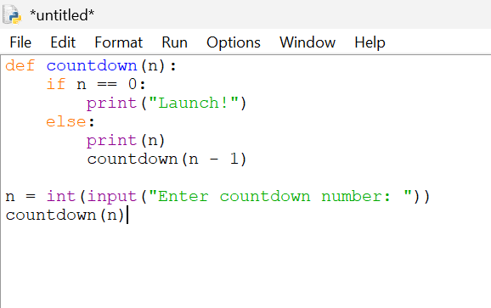
OUTPUT: 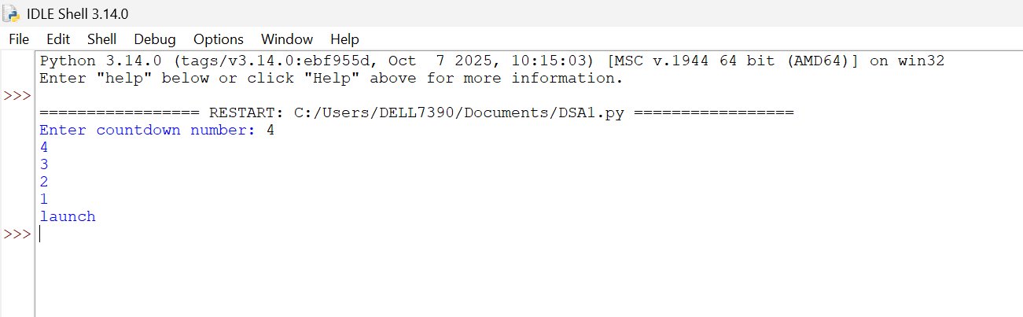EXPLANATION :This program displays a countdown from n to 1 and finally prints 'launch'. Although the aim mentions recursion, the given code uses a loop
ERROR TABLE :
S.NO | ERRORS | RECTIFICATION
1. | INDENTATION ERROR | USE 3 SPACES FOR EACH LEVEL OF INDENTATION
2. | TYPE ERROR | CONVERT THE INPUT TO AN INTEGER USING N=INT(INPUT(“ENTER NO.OF SECONDS TO LAUNCH : “))

1b)
AIM:The banks calculate the growth of an investment using compound interest; the formula requires calculating powers. Which can be implemented recursively. Write a recursive program to calculate p^n(power), where p=principal growth factor, n= number of years.
Program:
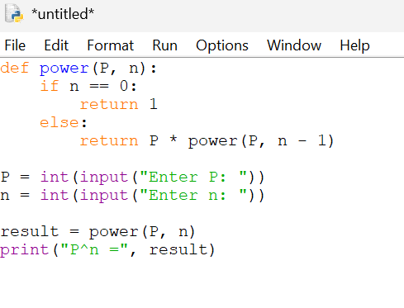
Output:
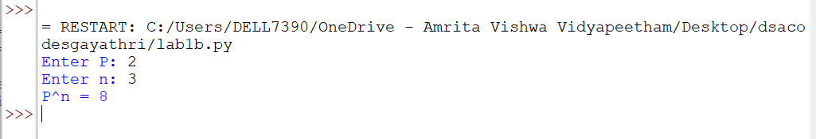
EXPLANATION: The function of power (p, n) calculates p^n using recursion by multiplying p with the result of power (p, n-1).
The recursion stops when n becomes 0, returning 1, which is the base case.
The final result is displayed after all recursive calls are completed.
ERROR TABLE :
S.NO | ERRORS | RECTIFICATION
1 | Type error | CONVERT THE INPUT TO FLOAT OR INT USING FLOAT(INPUT())OR INT(INPUT())
2 | Incorrect output if the recursive call is written as power(p,n+1) instead of power(p,n-1). | CHANGE THE RECURSIVE CALL TO POWER(P, n-1) so that n decreases toward the base case.

1c)
AIM: An HR department stores employee IDs in a list. Develop a recursive program to search for a given employee ID. Write a recursive function to search for an employee ID in a list. PROGRAM:
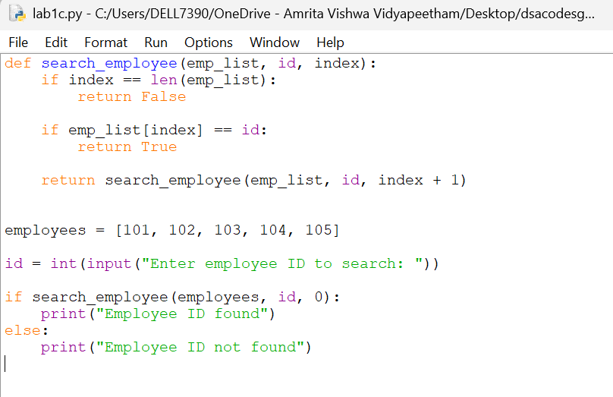
OUTPUT:

EXPLANATION:
The recursive function checks each employee ID in the list one by one, starting from the first element.
If the required ID is found, it returns True; otherwise, it continues searching recursively until the end of the list.
If the entire list is searched without finding the ID, the function returns False.
S.NO | errors | rectification
1. | Name error if the list name is misspelled | Use the correct variable name consistently throughout the program
2. | Syntax error due to a missing colon()after an if statement or function definition. | Add the missing colon (:) after if, else, or def.

1d)
AIM:
In a logistics company the number of possible ways to arrange n different parcels are calculated using the factorial formula(n!). develop a recursive program to calculate the factorial of a given number
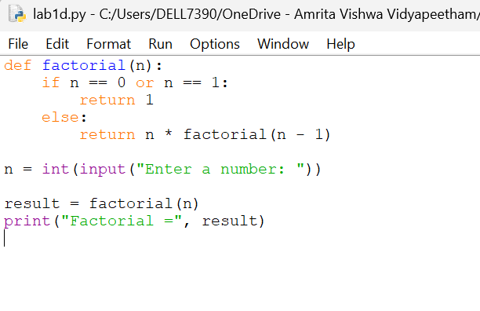

output:
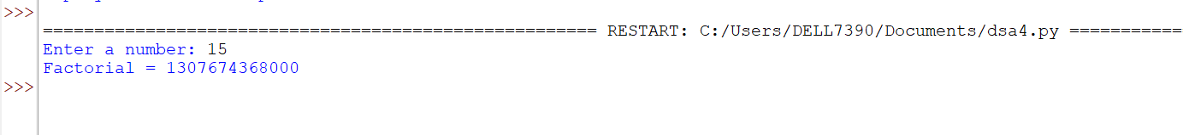

EXPLANATION: The function factorial(n) computes the factorial by multiplying the current number with the factorial of the previous number.
The recursion ends when n becomes 0 or 1, where the factorial value is 1.
The program also checks for negative inputs since factorial is defined only for non-negative integers.
s.no | errors | rectification
1 | IndentationError if the statements inside the function are not properly indented. | Maintain proper indentation (usually 4 spaces) inside the function.
2 | TypeError if a decimal number (e.g., 5.5) is entered for factorial calculation. | Enter only a whole number or convert the input using int().

1e)
AIM:
Write a recursive python program to print the first n terms of the Fibonacci series. PROGRAM:
Program:
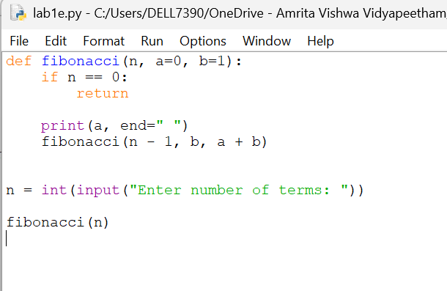
output:

EXPLANATION:
The function Fibonacci(n) returns the nth Fibonacci number by recursively adding the previous two Fibonacci numbers.
The base cases return 0 for the first term and 1 for the second term.
A for loop calls the recursive function repeatedly to print the first n terms of the Fibonacci series.
ERROR TABLE:
s.no | errprs | rectification
1 | Recursion Error if the base cases (n == 0 and n == 1) are not included. | Add both conditions before the recursive cell
2 | Value error if the user enters text instead of an integer | Enter a valid integer for no of terms

Lab-2
2a)
AIM:
Write a program to perform linear search on a given input.
PROGRAM:
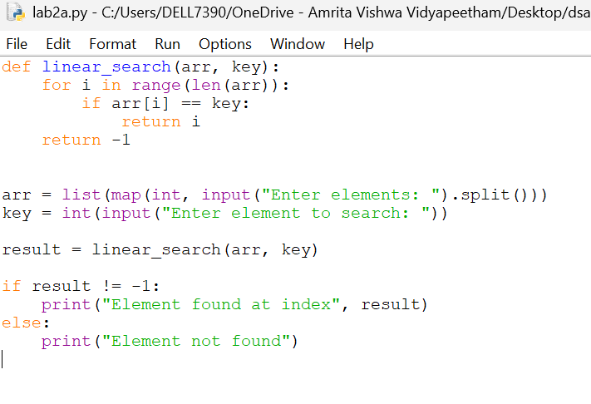
output 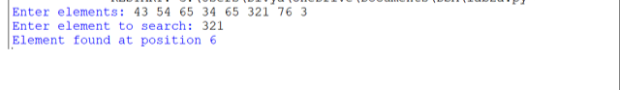

EXPLANATION:
The linear_search() function checks each element of the list one by one and compares it with the given key.
If the key is found, its index is returned; otherwise, the function returns -1.
The program takes the array and search element as input and displays whether the element is found.
ERROR TABLE:
s.no | errors | rectification
1 | ValueError occurs if a non-integer value is entered when int(input()) is used. | Enter only integer values for the number of elements and array elements.
2 | TypeError may occur if len(arr) is used on a variable that is not a list. | Make sure arr is initialized as a list using arr = [] and elements are appended to it.

2b)
AIM:
Write a Python program to perform binary search on the given input. Verify by taking sorted array and unsorted array as input.

PROGRAM:
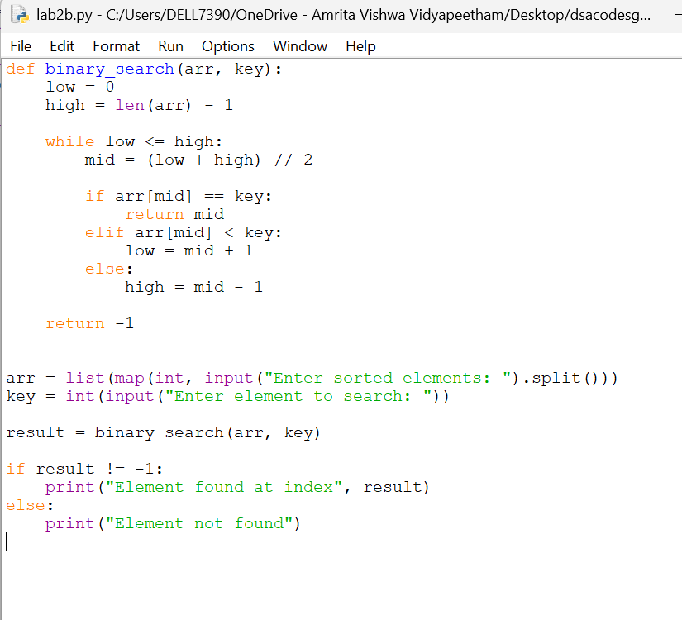
output:
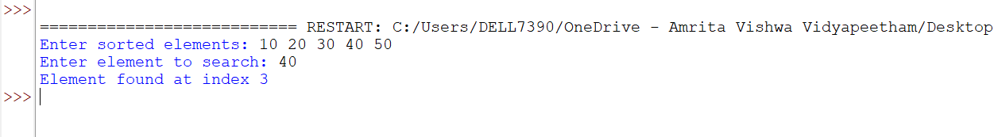

EXPLANATION:
The binary_search() function repeatedly divides the sorted list into two halves and compares the middle element with the search key.
If the middle element is smaller than the key, the search continues in the right half; otherwise, it searches the left half.
The second program verifies whether the input is sorted and sorts it using arr.sort() if necessary before performing binary search.
Error table :
s.no | errors | Rectification
1. | Wrote the mid formula outside the while loop which gave the infinite loop error | Added the mid formula inside the while loop

2c)
Aim:
Write a program for implementation of binary search along with the sorting the elements
Program:
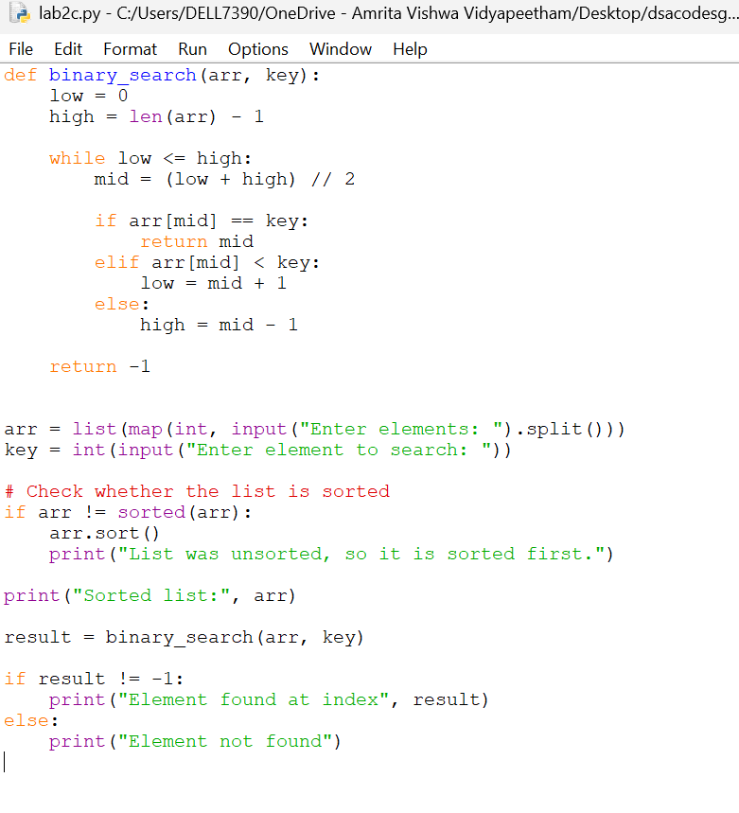

Output:
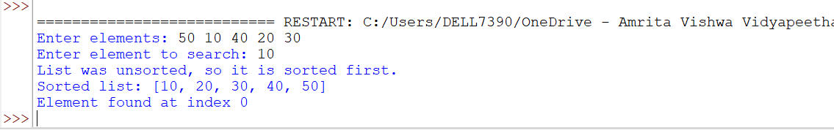
Error table :
error | rectification
Used sorted method instead of which need to be referred to another variable as it returns a sorted array | Used the arr.sort() method which directly sorts the arr without using another variable
Explanation :
The program first takes the input elements and the element to be searched.
It checks whether the list is sorted; if not, it sorts the list using sort().
Then, it applies binary search by repeatedly checking the middle element.
If the element is found, its index is displayed; otherwise, it prints Element not found.

Lab-3
3a).
AIM:
write programs for the Bubble sort
program:
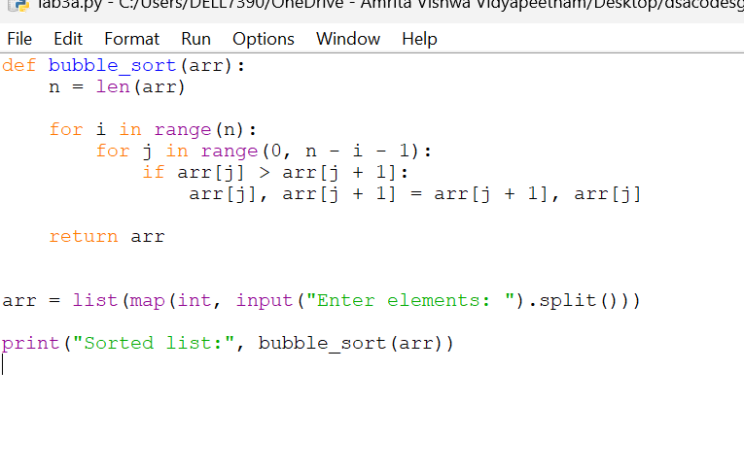
output: 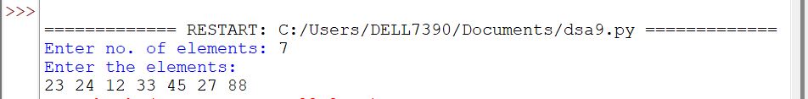
Explanation: Bubble sort compares two adjacent elements. If the left element is greater than the right element, they are swapped. After each pass, the largest remaining element moves to the end.
Error table:
s.no | error | correction
1 | Used wrong loop range | Use for j in range(n-i-1):
2 | Swap condition is wrong | Use if arr[j] > arr[j+1]:

3b)
AIM:
write programs for the Insertion sort
PROGRAM:
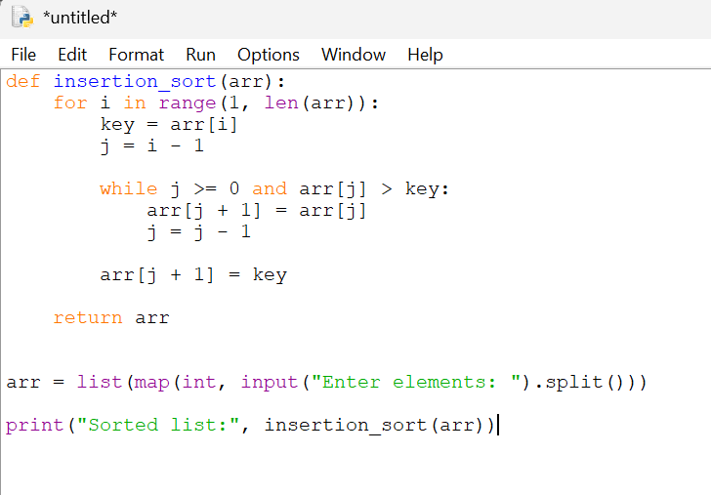
Output:
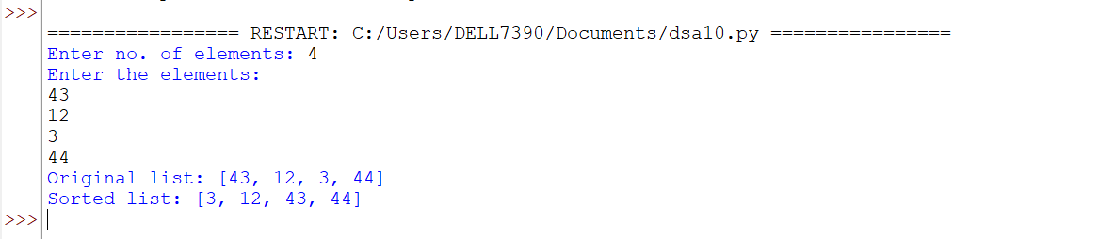

Explanation: Insertion sort builds the sorted array one element at a time.
it takes one element called the key, compares it with the elements before it, shifts larger elements to the right, and inserts the key in the correct position.

Error table:
s.no | error | correction
1 | key is not stored properly | Use key = arr[i]
2 | arr[j+1] = key placed inside while loop | Place it after the while loop

3c)AIM:
write programs for the Bubble sort 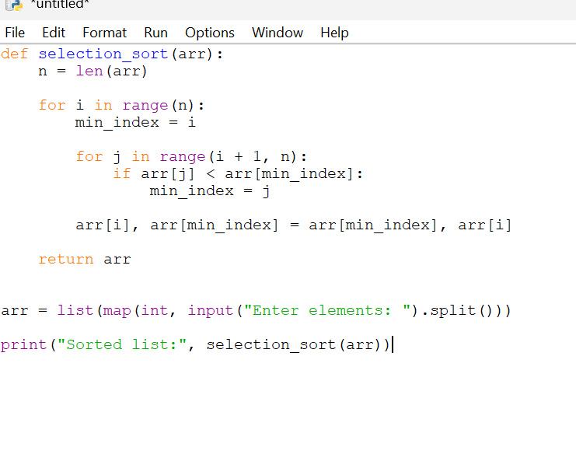
output:
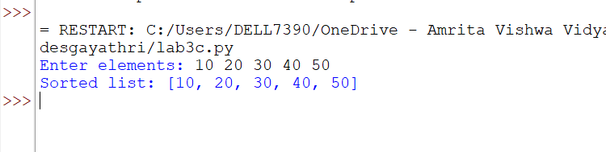
Explanation:
Selection sort repeatedly finds the smallest element from the unsorted part of the array and places it in its correct position.
Error table:
s.no | error | Correction
1 | min_index is not initialized | Use min_index = i
2 | Swap is placed inside inner loop | Place swap after the inner loop

Lab 4
4a)
Aim:
Write a python program to implement merge sort where the input elements are taken from the user.
Program:
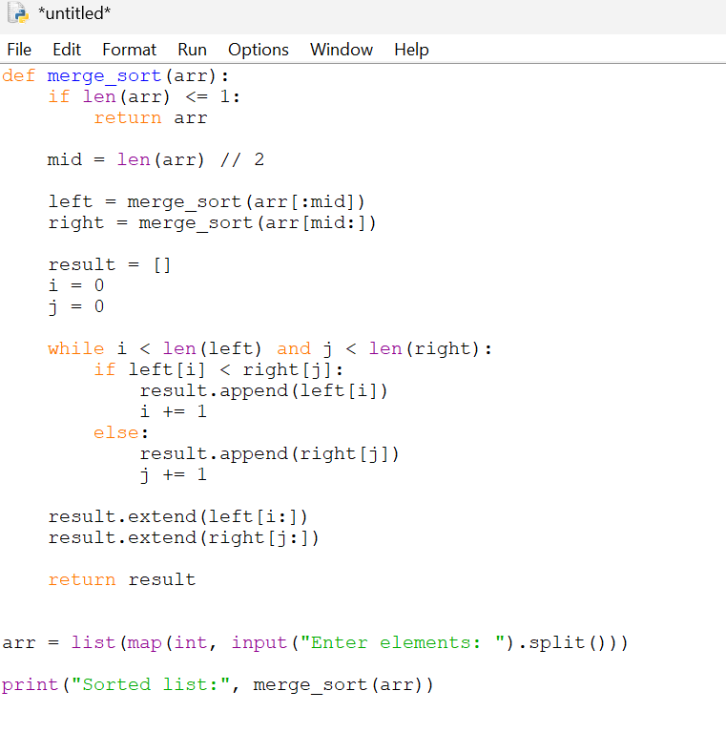

Output:
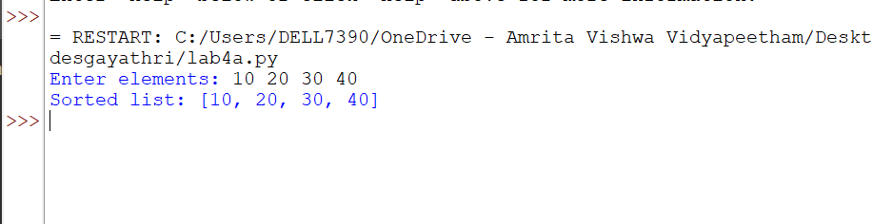
error | rectification
TypeError: object of type 'NoneType' has no len() | Taken return arr at end of merge_sort.
Error table:

Description :
• The program implements the Merge Sort algorithm.
• The user enters the size of the array.
• The elements are taken from the user and stored in a list.
• The merge_sort() function recursively divides the array into two halves.
• The array is divided until each sub-array contains one or zero elements.
• The left and right portions are then sorted recursively. • The sorted left and right arrays are compared element by element.
• The smaller element is placed into the original array.
• Remaining elements from either portion are then copied into the array.
• Finally, the completely sorted array is displayed.
• Merge Sort follows the divide-and-conquer approach.
4b)
AIM:
Write a python program to implement quick sort where the input elements are taken from the user.
PROGRAM:
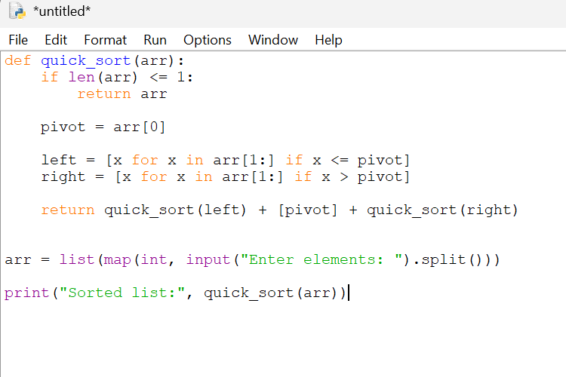

OUTPUT:
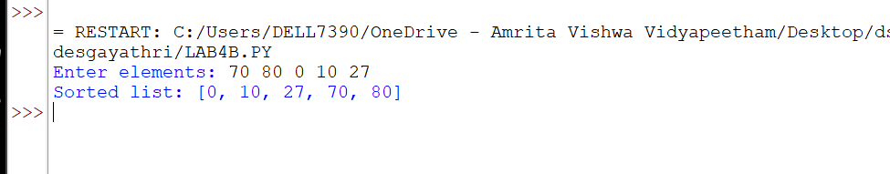

ERROR TABLE:
ERROR | RECTIFICATION
i < len(a) checks the complete array instead of current subarray | Use i <= high and maintain correct partition boundaries
Description:
• The program implements the Quick Sort algorithm.
• The user enters the size of the array.
• The elements are taken from the user and stored in a list.
• The quick_sort() function is used to sort the array recursively.
• The first element of the current portion is selected as the pivot.
• Two pointers, i and j, are used to compare elements with the pivot.
• i moves from the left side and searches for an element greater than or equal to the pivot. • j moves from the right side and searches for an element smaller than or equal to the pivot.
• If i < j, the two elements are swapped.
• After the partitioning process, the pivot is placed in its correct position.
• The array is then divided into left and right portions.
• Quick Sort is recursively applied to both portions.
• Finally, the sorted array is printed.

WEEK-5
5a)
Aim:
Write a Python program to implement a Singly Linked List (SLL) with the following operations:
1. Create LL
2. Insert at Beginning
3. Insert at End
4. Insert at Index
5. Delete by Value
6. Delete Prior Node
7. Delete Last Node
8. Count Number of Nodes
9. Display/Traverse
10. Exit

Program:
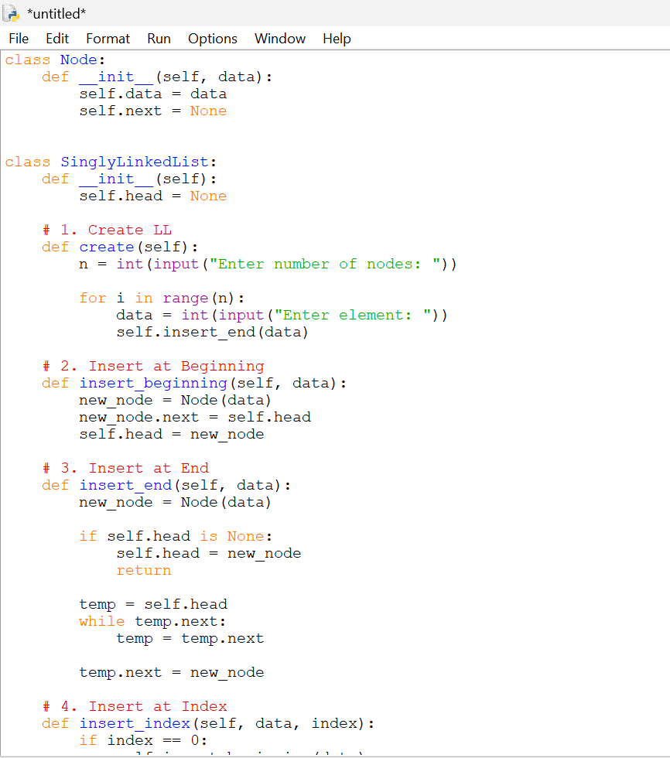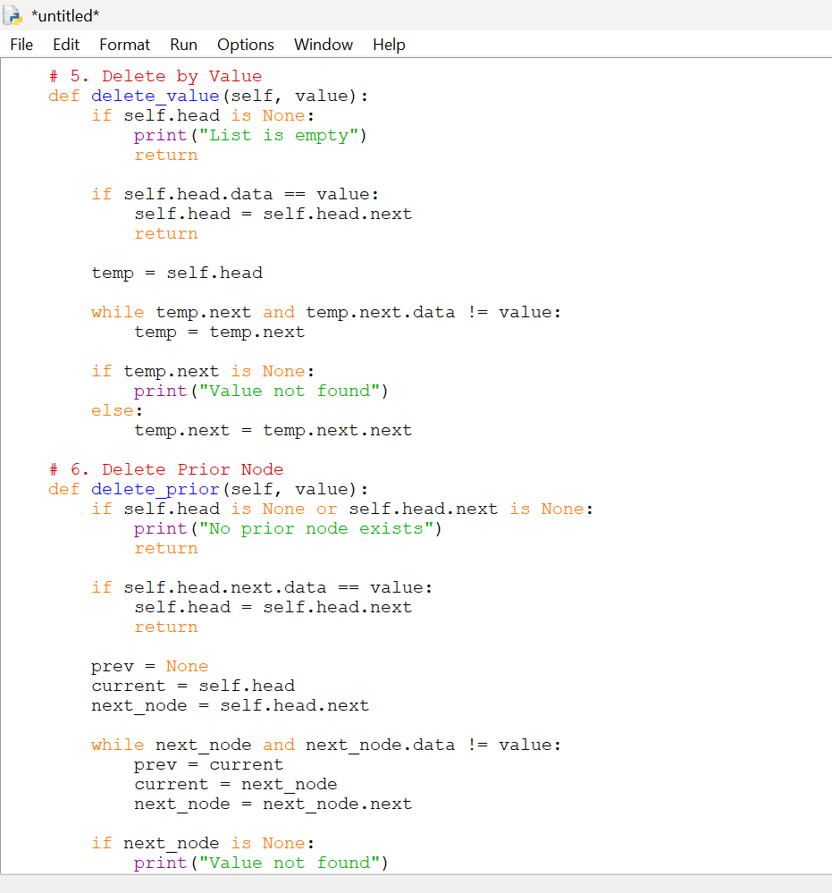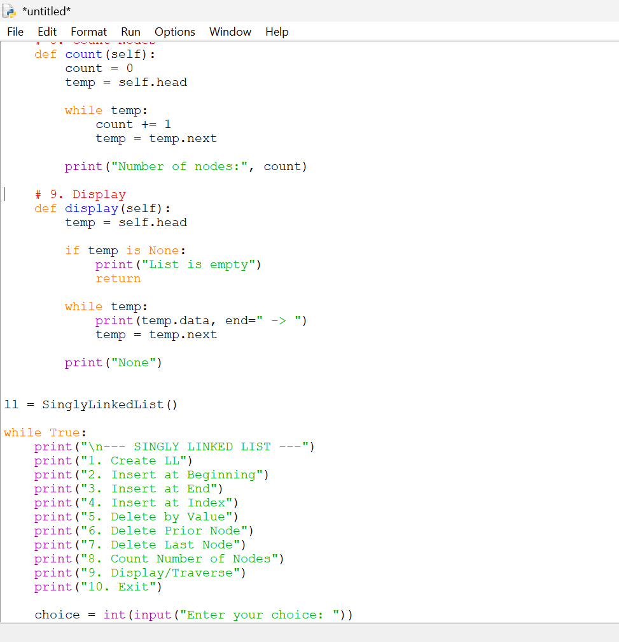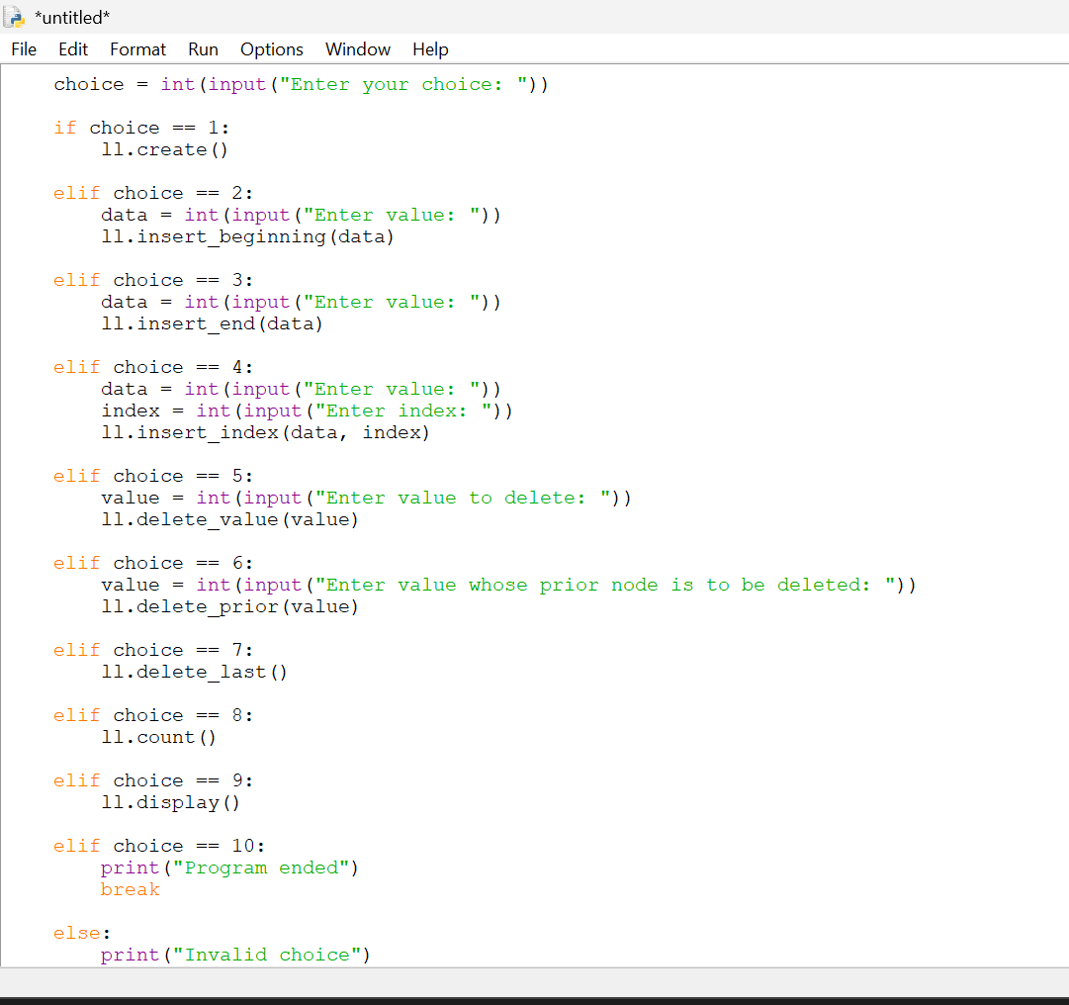

Output:
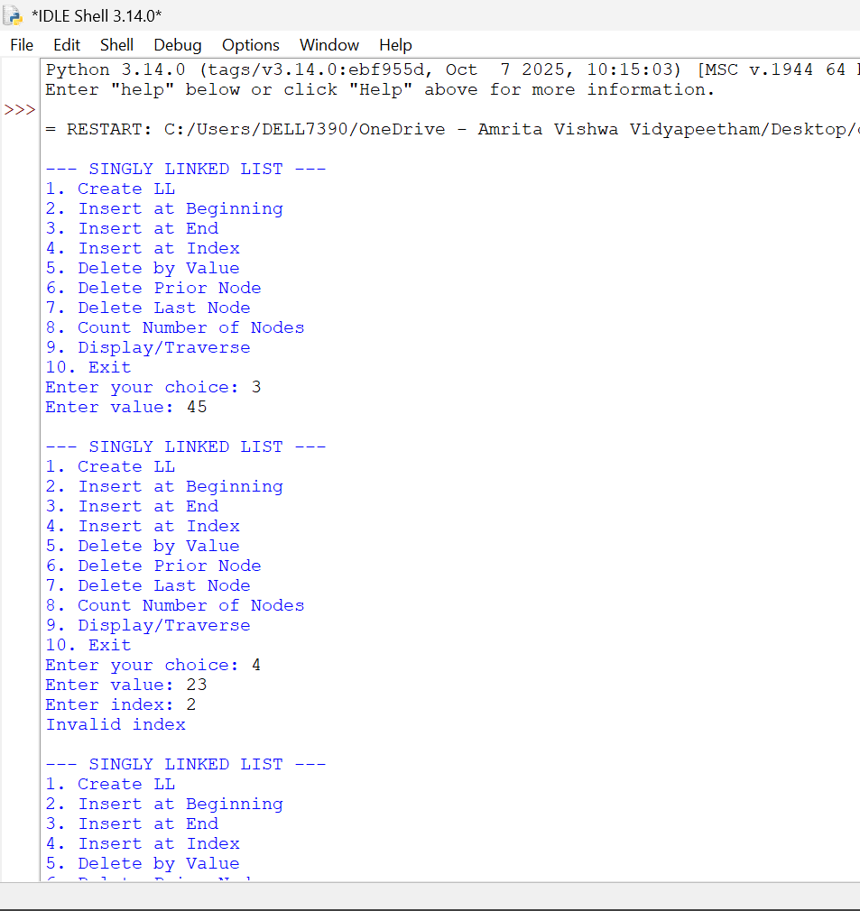

Error table:
error | rectification
The program may display an incorrect message for insertion at a specific index even when the index is invalid | Check whether the index is valid before displaying the successful insertion message.
Description: • The program implements a Singly Linked List using Python classes.
• The Node class is used to create individual nodes.
• Each node contains two parts: data and next.
• data stores the value of the node.
• next stores the reference to the next node.
• The SingleLinkedList class manages the linked list.
• The head variable stores the reference to the first node.
• The program provides an option to create a linked list.
• It supports insertion at the beginning of the list.
• It supports insertion at the end of the list.
• It supports insertion at a specific index.
• It supports deletion of a specific value.
• It supports deletion of the first node.
• It supports deletion of the last node.

5b)
Aim:
Write a Python program to implement a Double Linked List (DLL) with the following operations:
1. Create LL
2. Insert at Beginning
3. Insert at End
4. Insert at Index
5. Delete by Value 30
6. Delete Prior Node
7. Delete Last Node
8. Count Number of Nodes
9. Display/Traverse
10. Exit
Program:
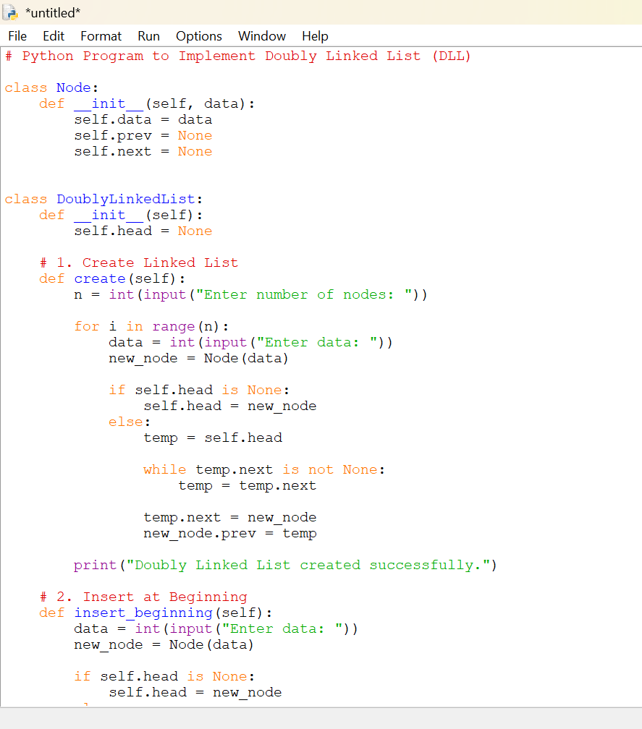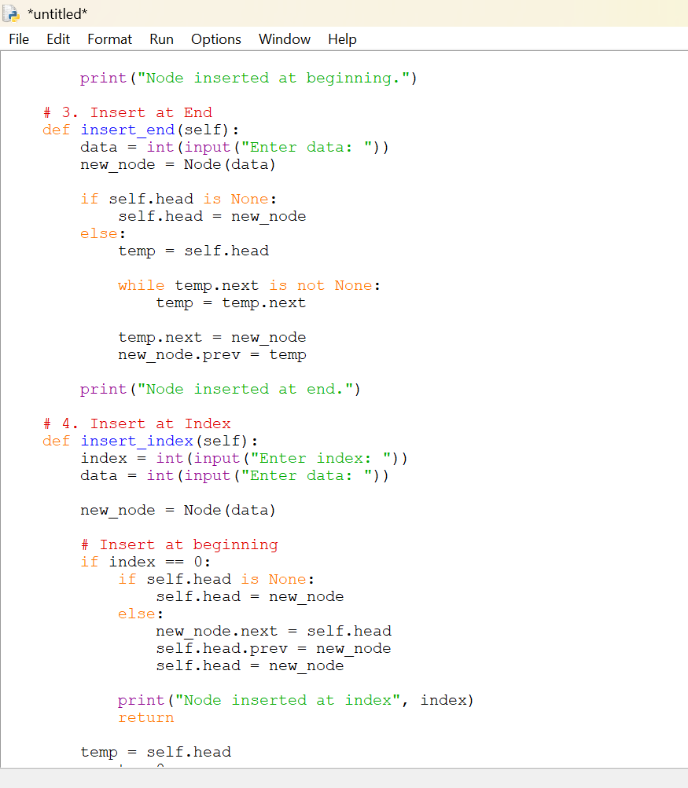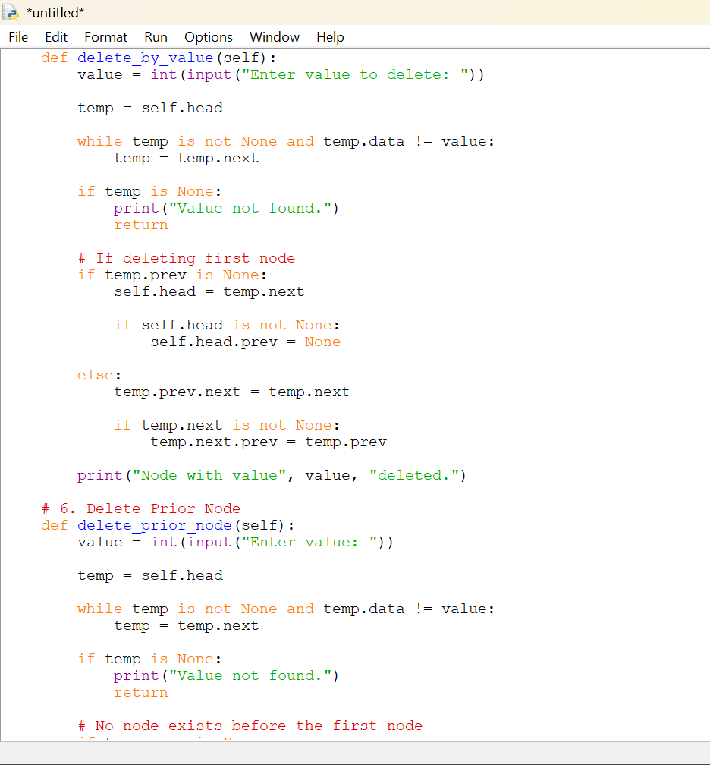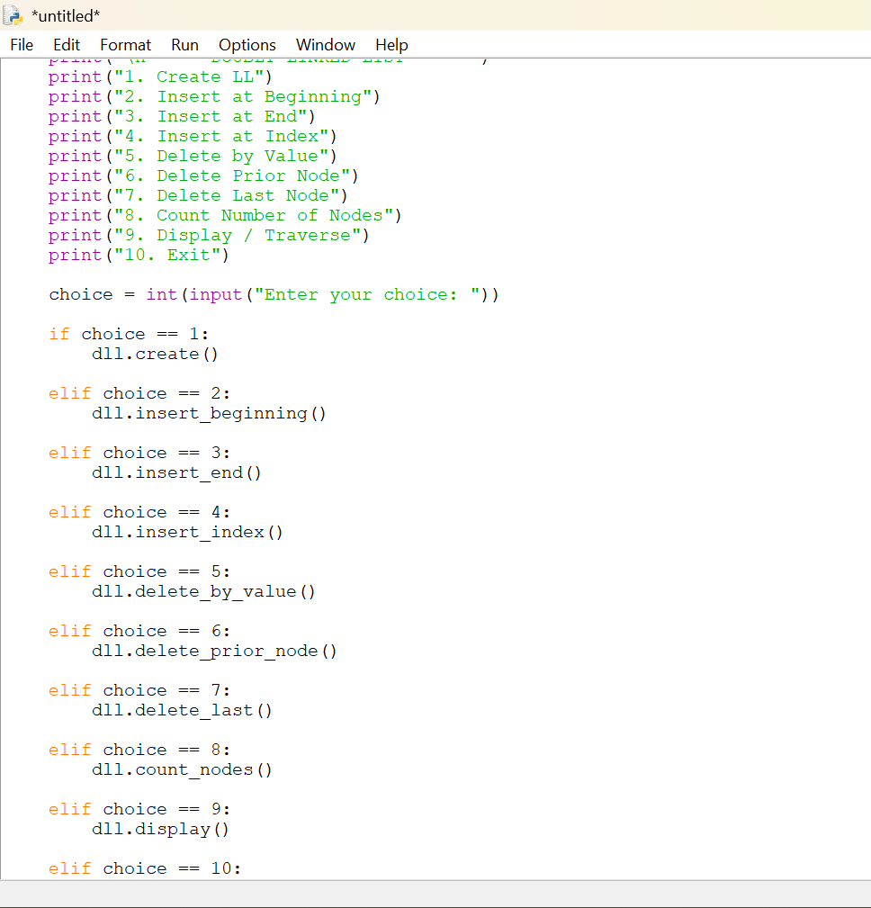

Output:
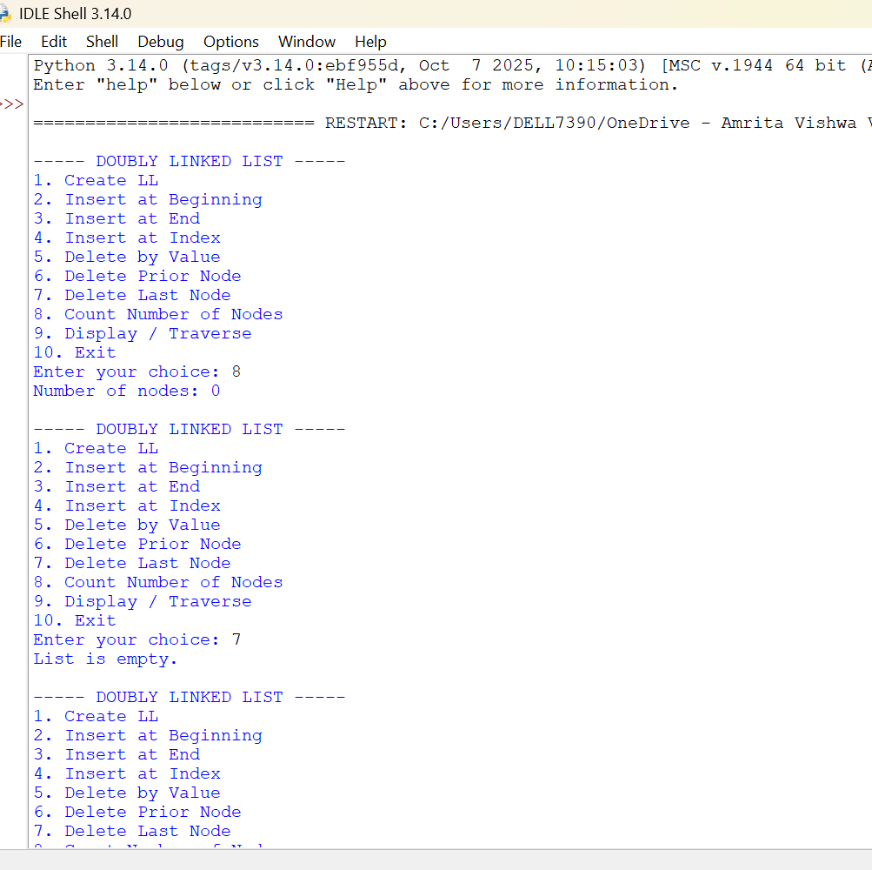

Error table:
error | rectification
The prev and next links may not be updated correctly during insertion or deletion. | Update both links whenever a node is inserted or deleted.
Description:
• The program implements a Doubly Linked List using Python classes.
• The Node class is used to create individual nodes.
• Each node contains three parts: data, prev, and next.
• data stores the value of the node.
• prev stores the reference to the previous node.
• next stores the reference to the next node.
• The DoubleLinkedList class is used to manage the linked list.
• The head variable stores the reference to the first node.
• The program provides an option to create a doubly linked list.
• It supports insertion at the beginning of the list.
• It supports insertion at the end of the list.
• It supports insertion at a specific index.
• It supports deletion of a specific value.
• It supports deletion of the first node.
• It supports deletion of the last node.
• It provides a function to count the number of nodes.

5c)
Aim:
Write a Python program to implement a Circular Linked List (CLL) with the following operations: 1. Create LL
2. Insert at Beginning
3. Insert at End
4. Insert at Index
5. Delete by Value
6. Delete Prior Node
7. Delete Last Node
8. Count Number of Nodes
9. Display/Traverse
10. Exit

Program:
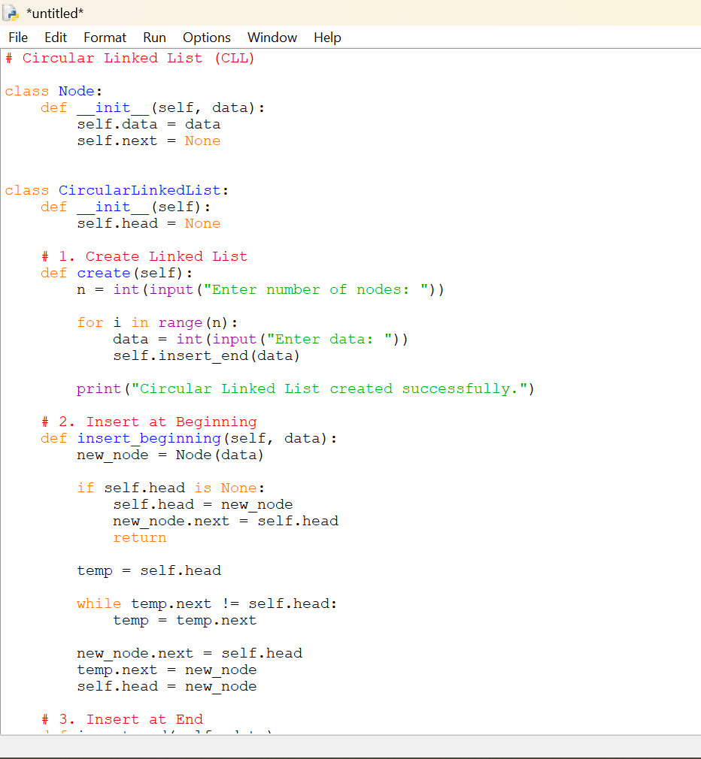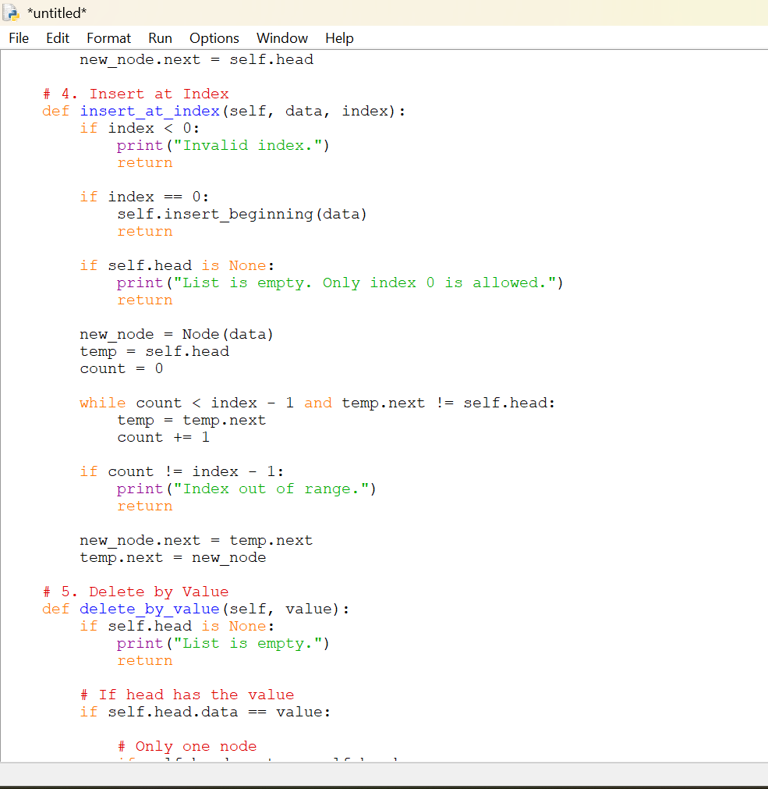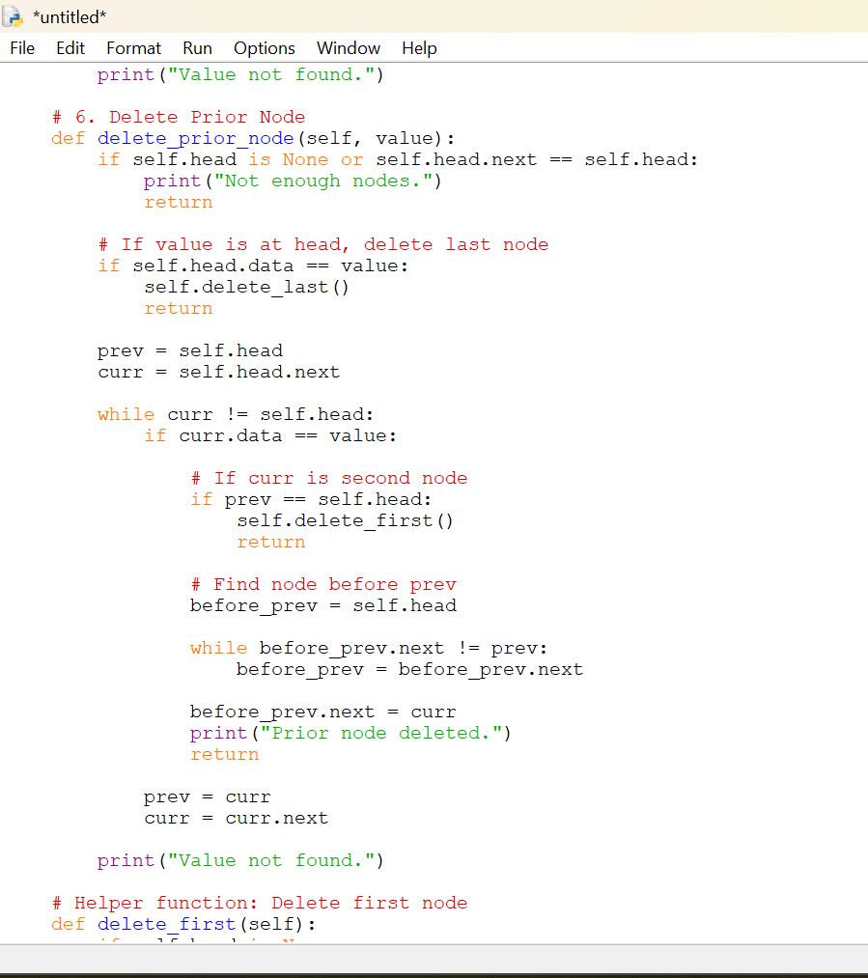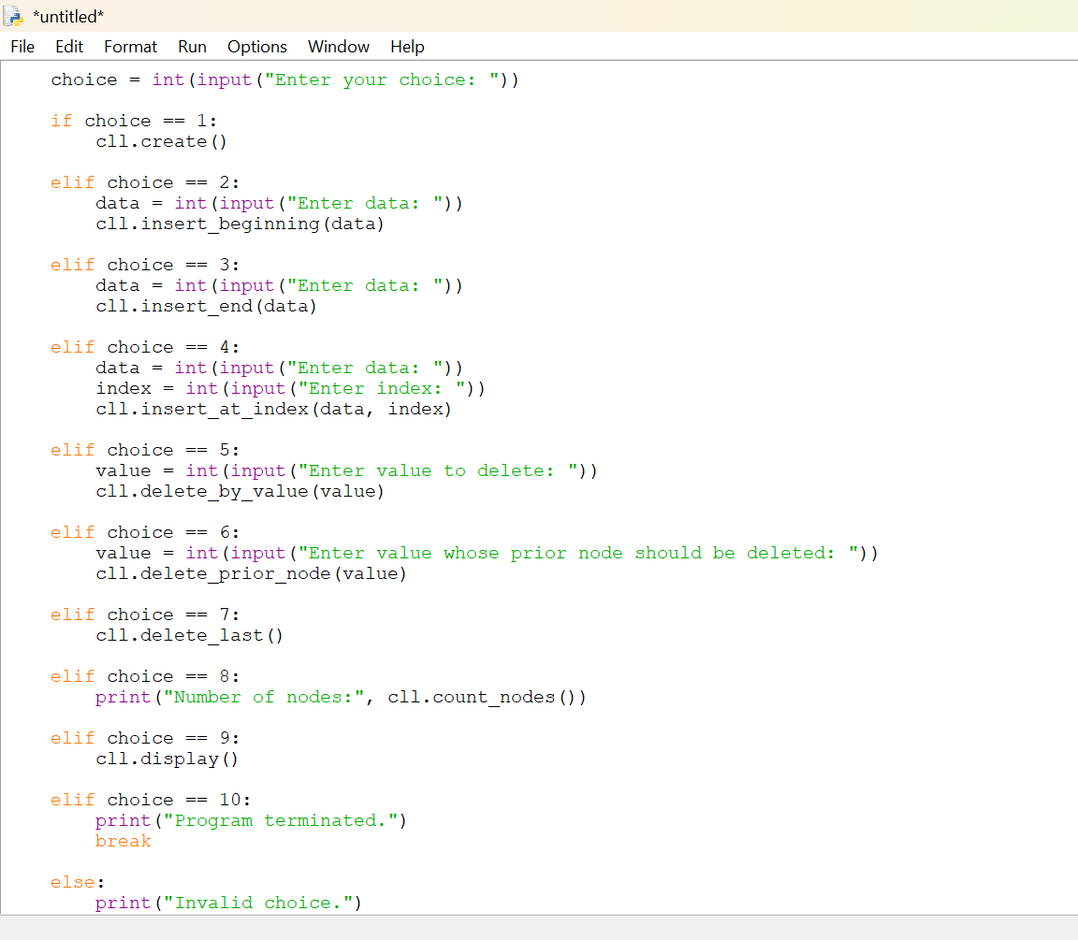

Output:
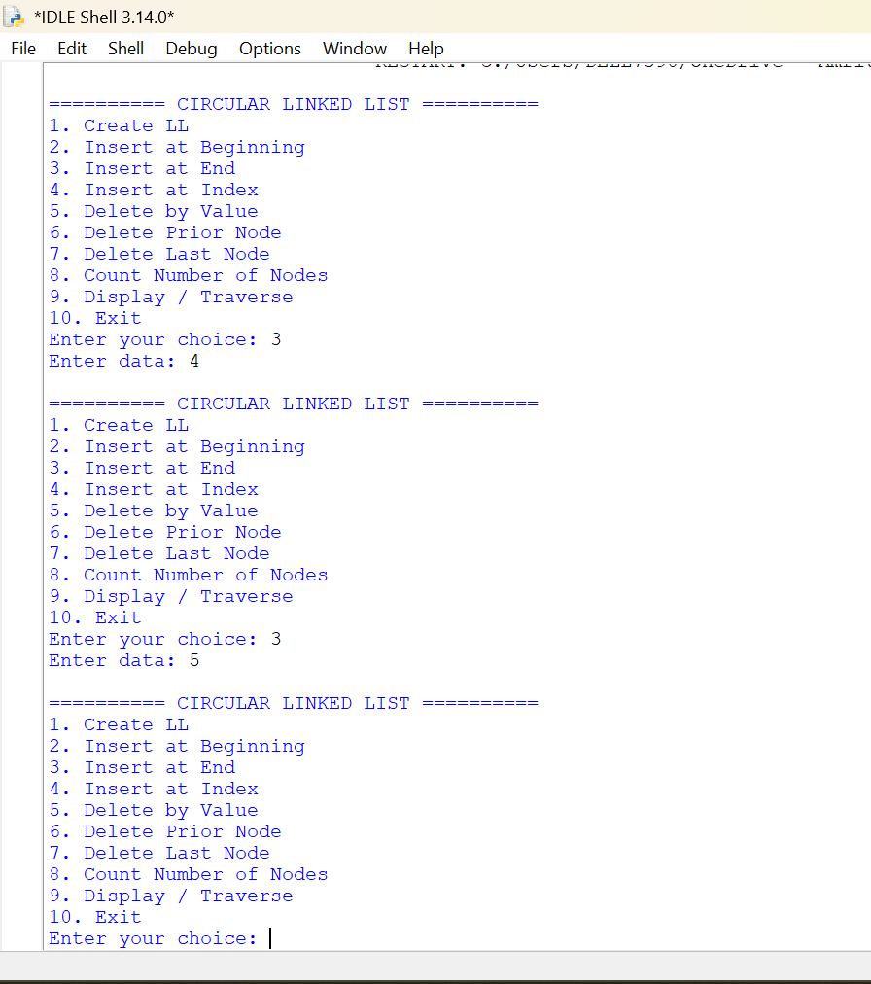

Error table:
Error | rectification
No major error is present in the given program. | No major rectification is required.
Description:
• The program implements a Circular Linked List using Python classes.
• The Node class is used to create individual nodes.
• Each node contains two parts: data and next.
• data stores the value of the node.
• next stores the reference to the next node.
• In a Circular Linked List, the last node points back to the first node.
• The CircularLinkedList class is used to manage the linked list.
• The head variable stores the reference to the first node.
• The program provides an option to create a circular linked list.
• It supports insertion at the beginning of the list. 44
• It supports insertion at the end of the list.
• It supports insertion at a specific index.

Week-6
6a)
Aim:
Write a Python program to implement stack operations such as Push, Pop, Peek, and Display using an Array.
Program: 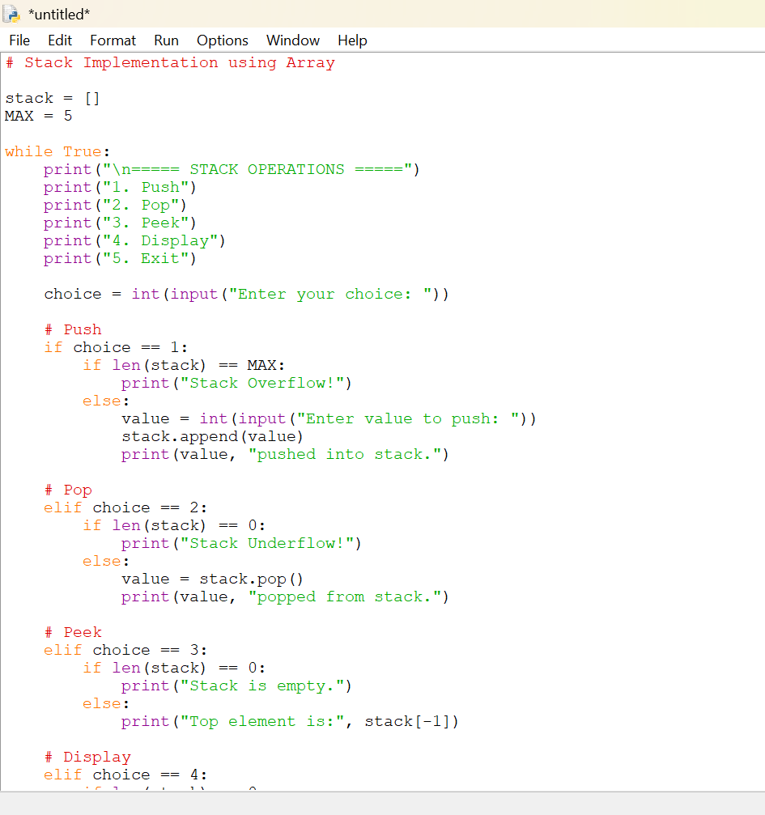
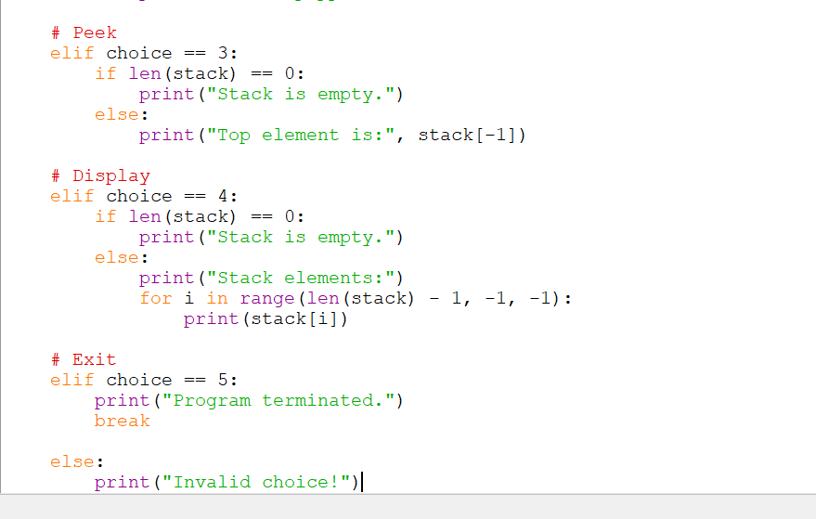
Output:
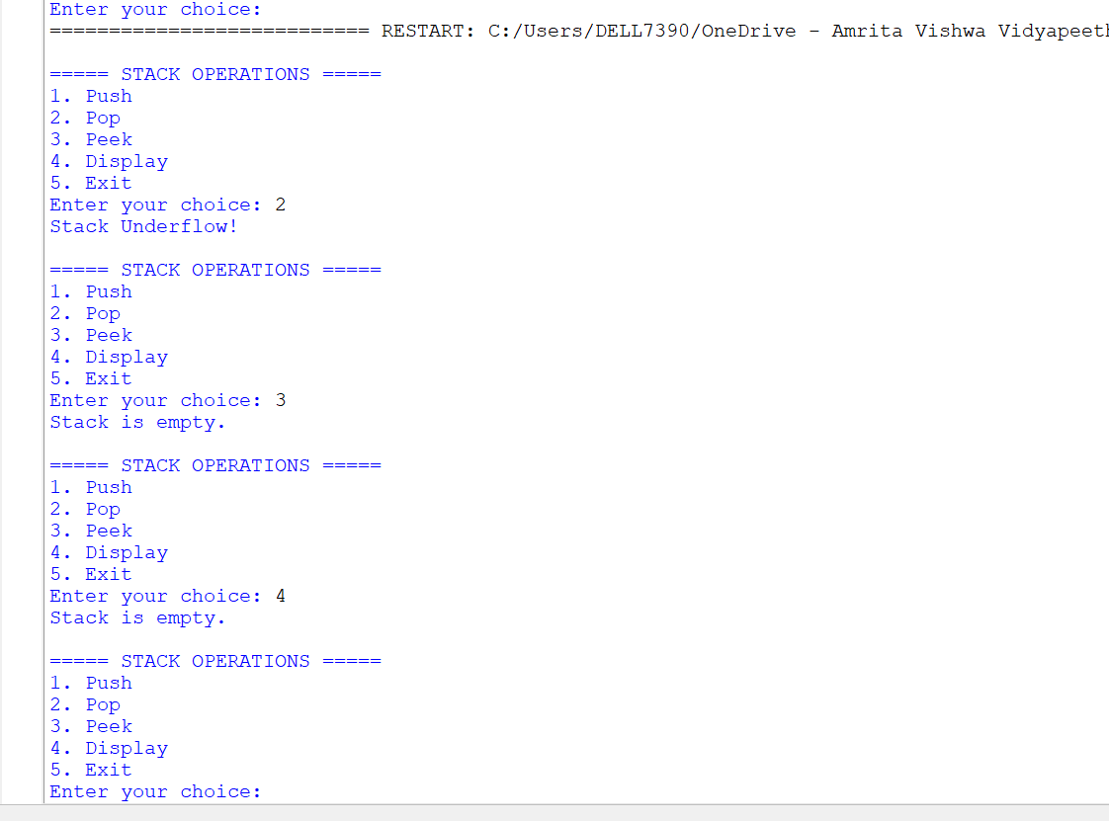
Error table:
Error | Rectification
In peek, self.peek is taken in ‘if’ does not give correct answer for stack underflow. | Self.top is taken in ‘if’ to give correct output.
Description:
• The Stack class implements a stack using a Python list.
• size stores the maximum size of the stack.
• stack stores the stack elements.
• top keeps track of the top position. Initially, top = -1, meaning the stack is empty.
• Push adds an element to the top of the stack.
• Pop removes the top element from the stack. 48
• Peek displays the top element without removing it.
• Display prints all elements from top to bottom.
• Stack Overflow occurs when trying to push into a full stack.

6b)
2.Aim: Write a Python program to implement stack operations such as Push, Pop, Peek, Display using a linked list.
Program:
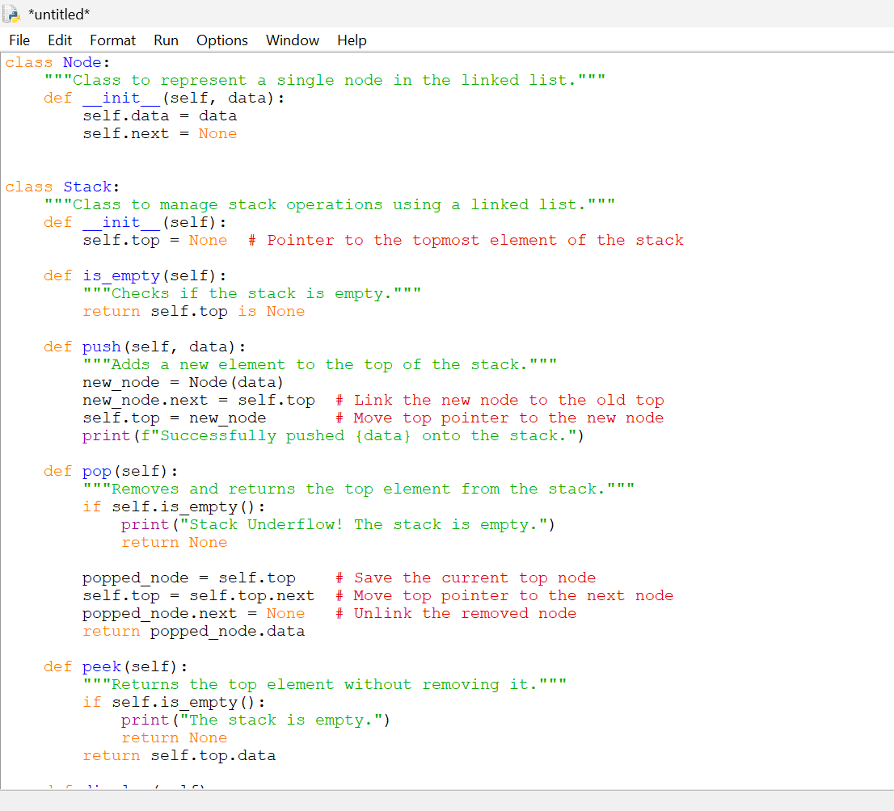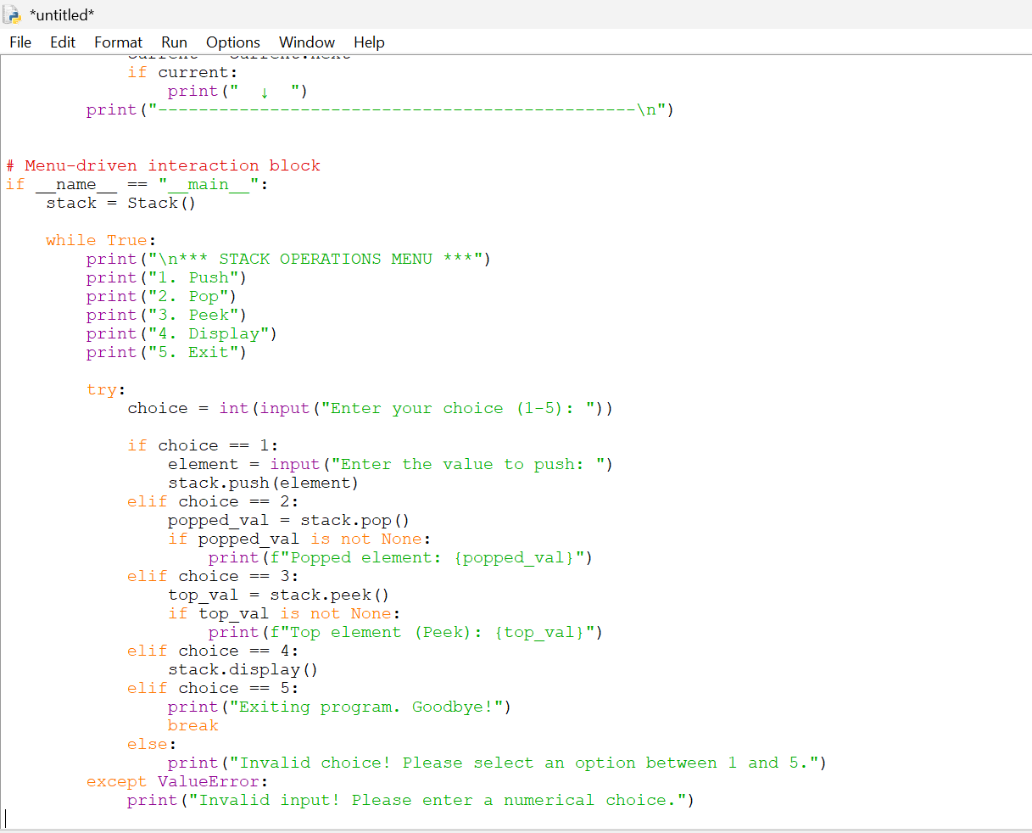

Output:
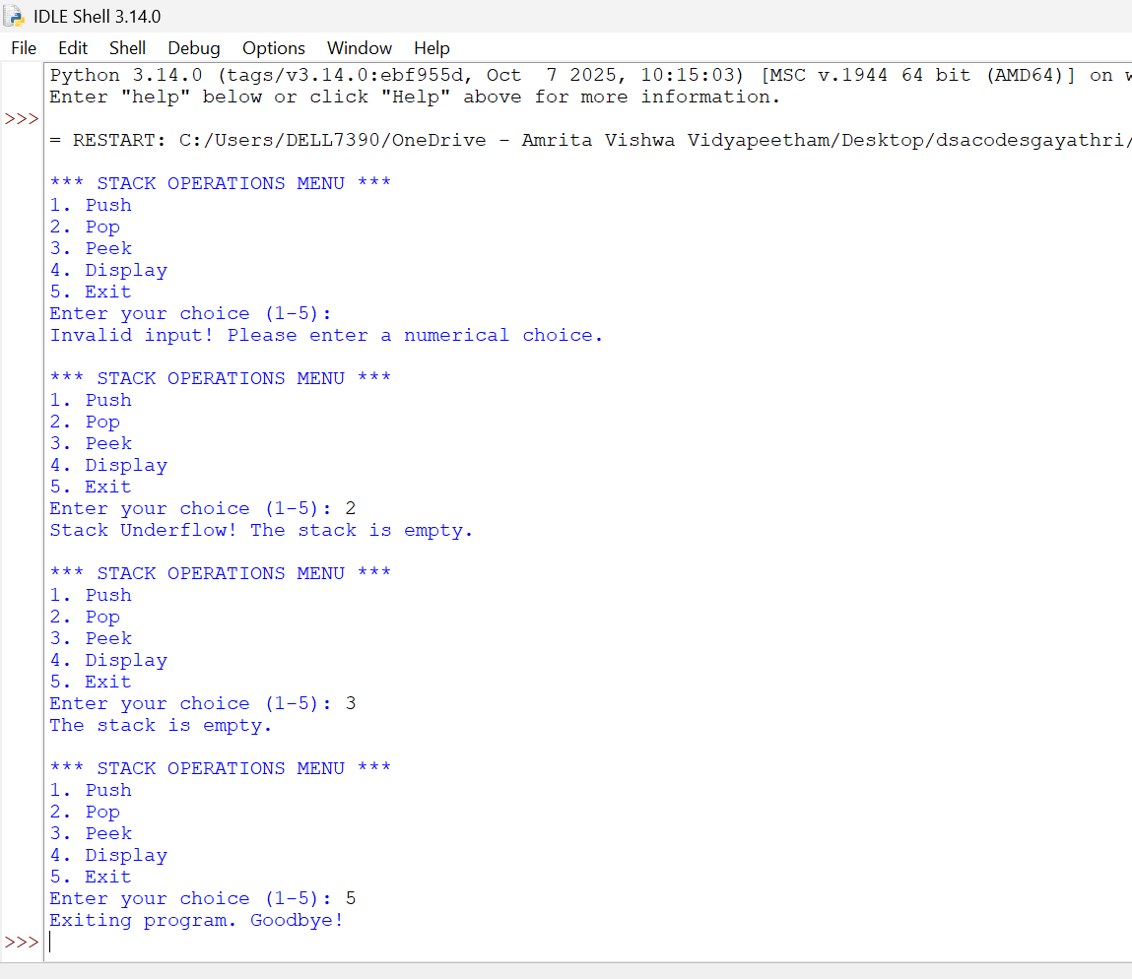

Explanation: A linked-list stack consists of nodes. A temporary pointer travels through the linked list:

Error table:
s.no | Error | Correction
1 | AttributeError | Check self.top is None before accessing date
2 | Stack Underflow | Check whether top is None

Lab -7
1.Aim :
Write a Python program to implement a queue and its operations such as Enqueue, Dequeue, Peek, Display with a menu-driven approach. Implement using array
PROGRAM: 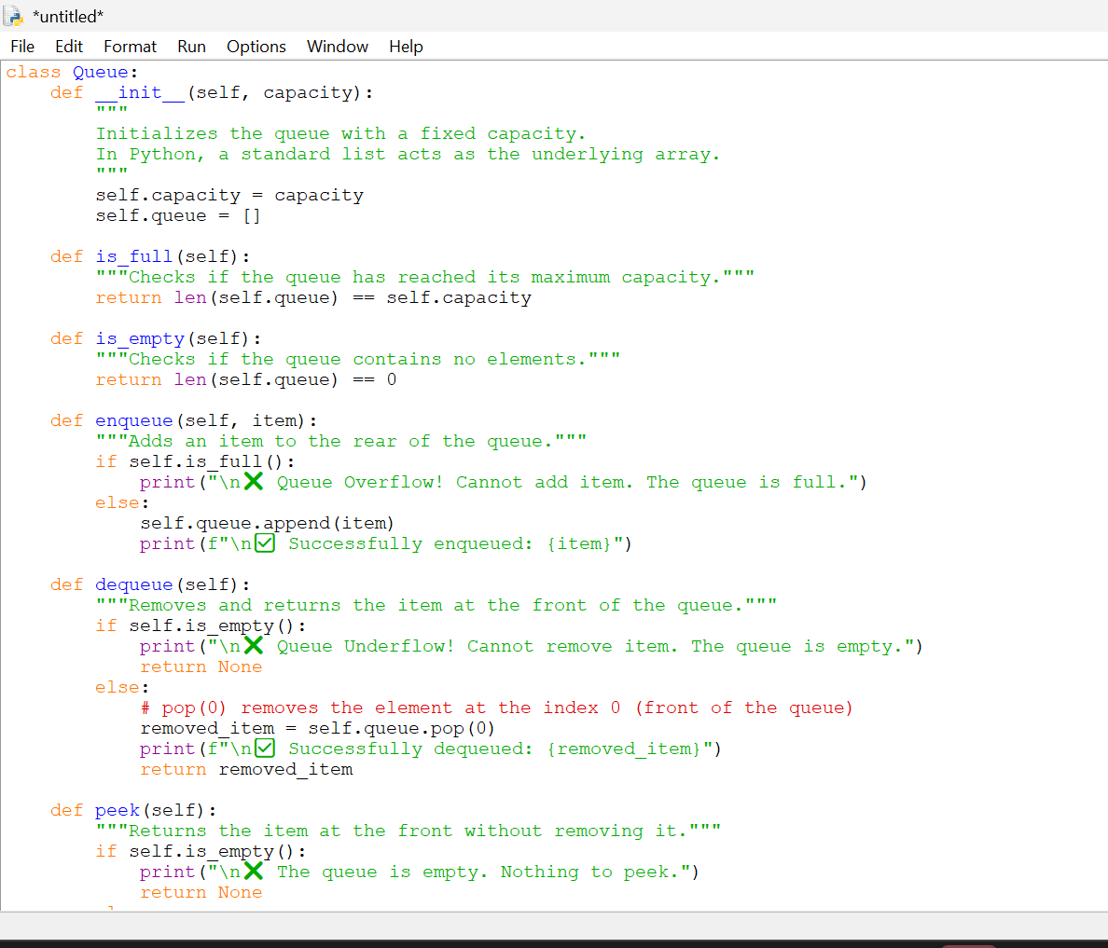

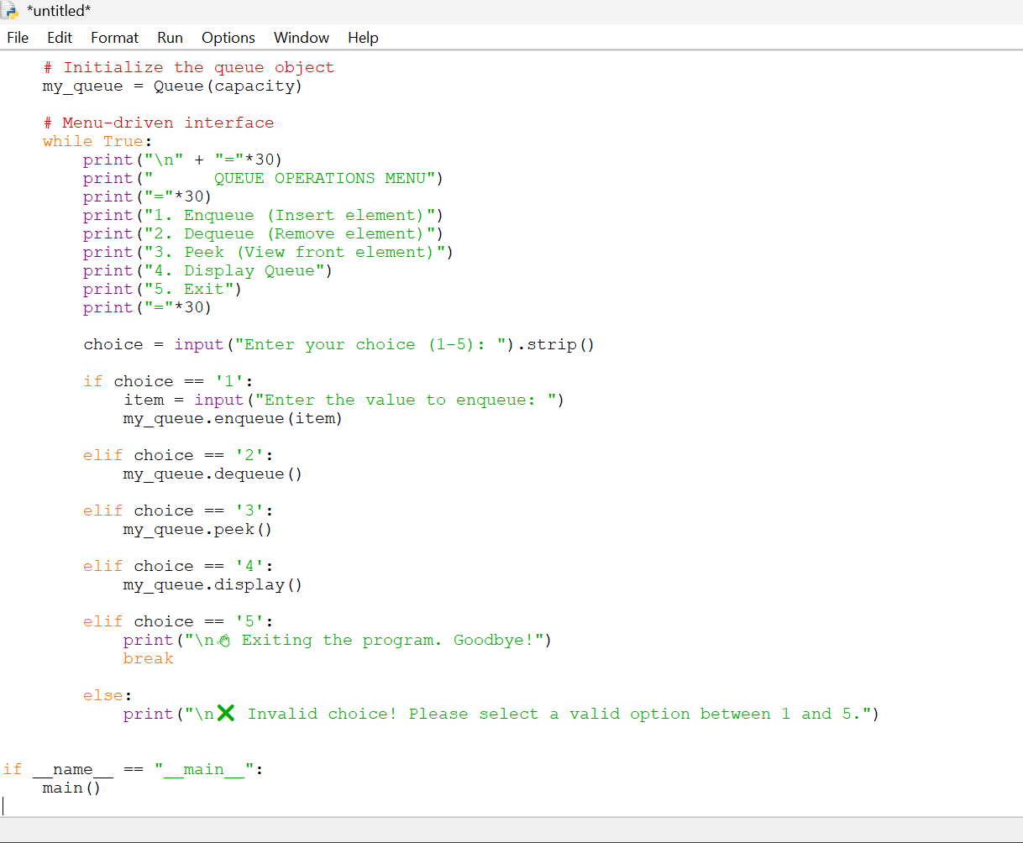

OUTPUT:
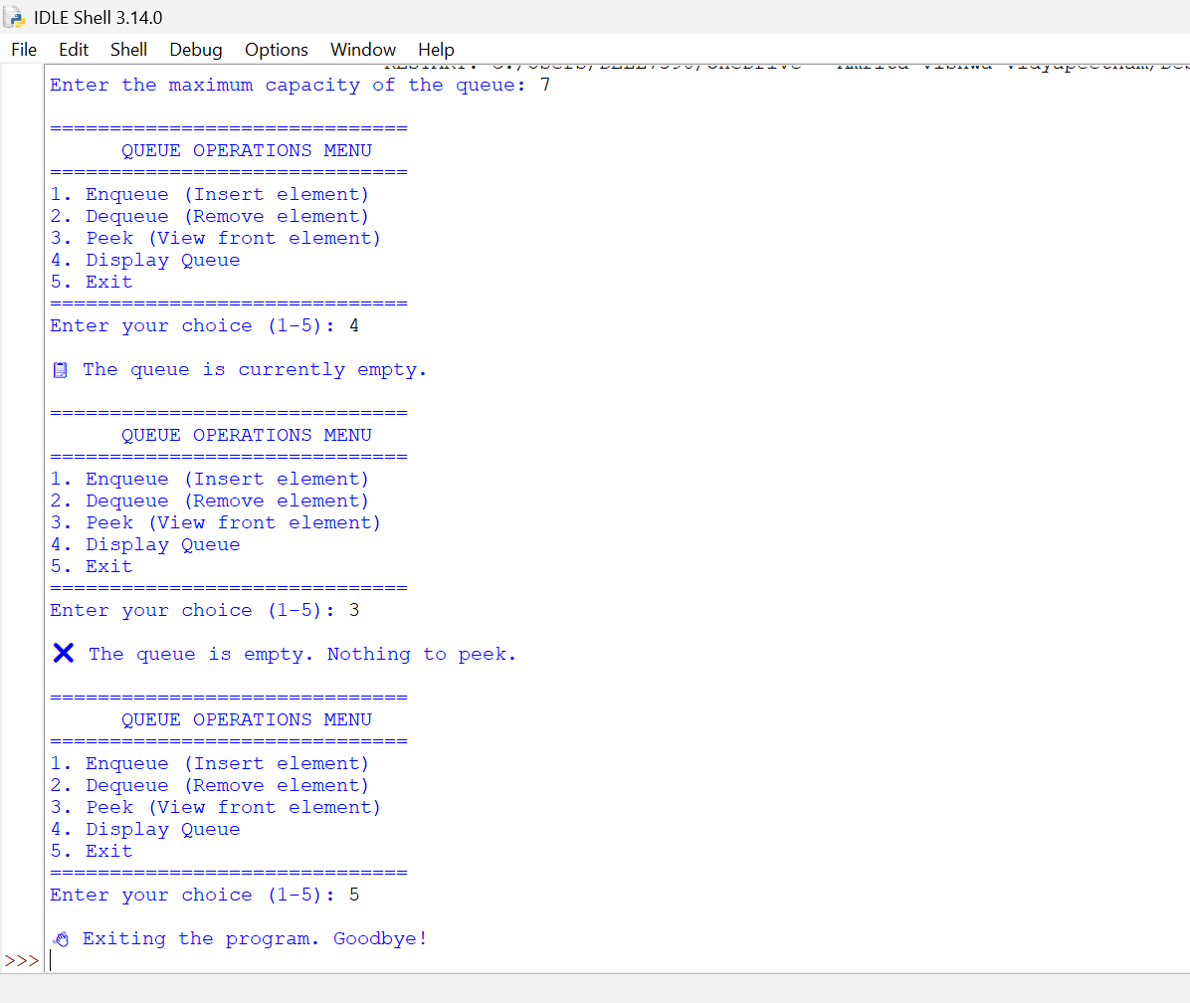

Explanation: A queue is a linear data structure that follows the FIFO (First In, First Out) principle. In this program, Python's list is used as an array to store queue elements.

ERROR TABLE:
1 | Using queue.pop() instead of queue.pop(0) removes the last element instead of the front element. | Use queue.pop(0) for dequeue operation.
2 | Not checking the queue size before insertion can cause the queue to exceed its maximum size. | Check if len(queue) == MAX_SIZE before enqueue.

7B)
2.Aim: Write a Python program to implement a queue and its operations such as Enqueue, Dequeue, Peek, Display with a menu-driven approach. Implement using linked-list data structures.
PROGRAM:
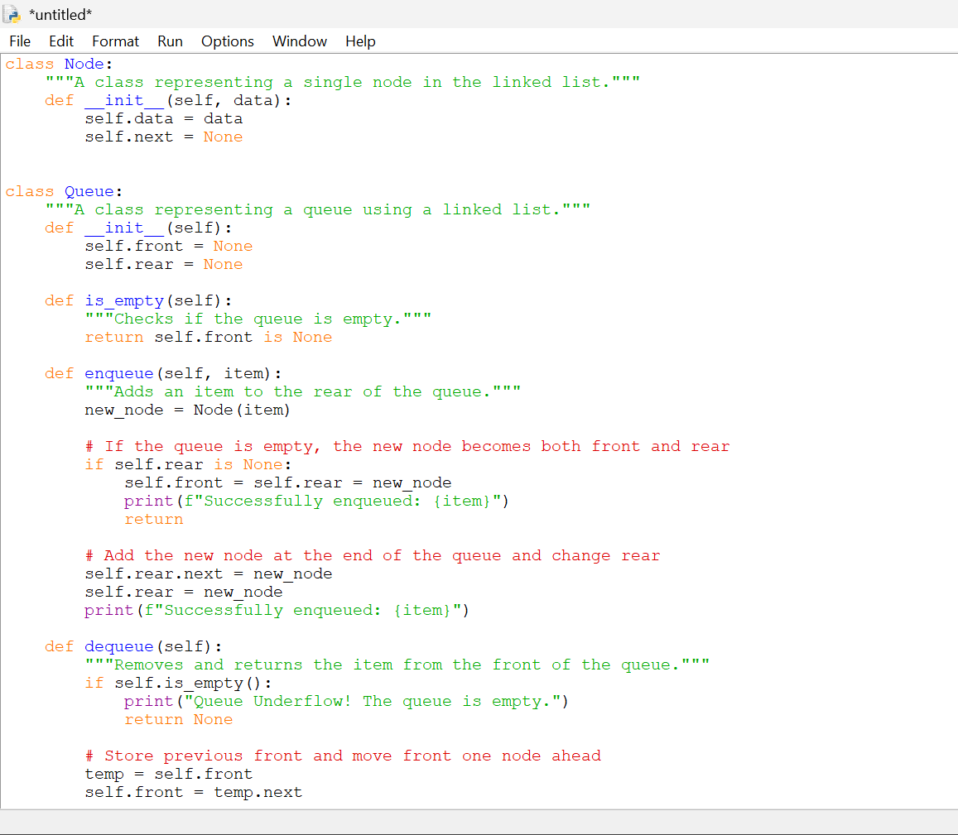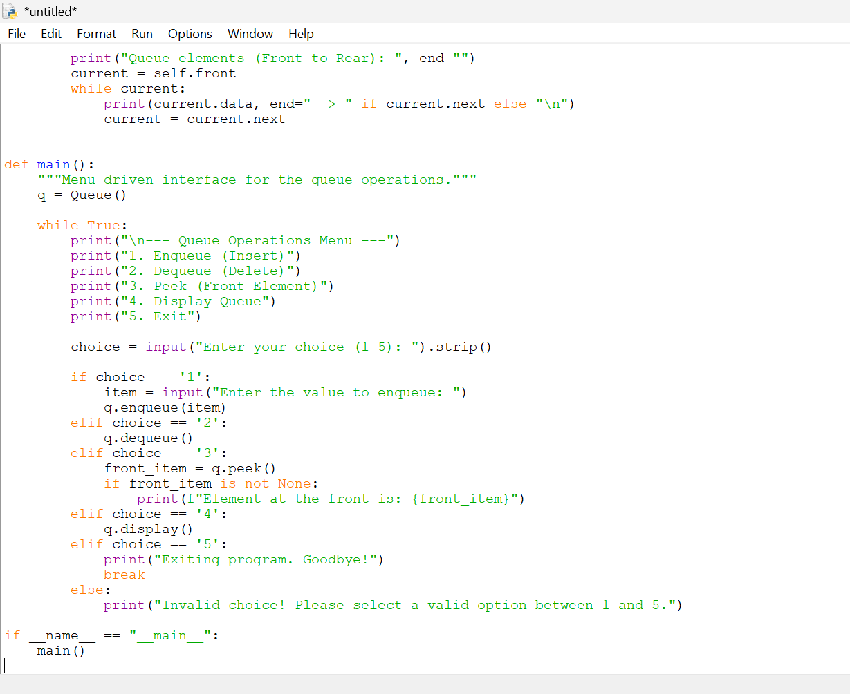

OUTPUT:
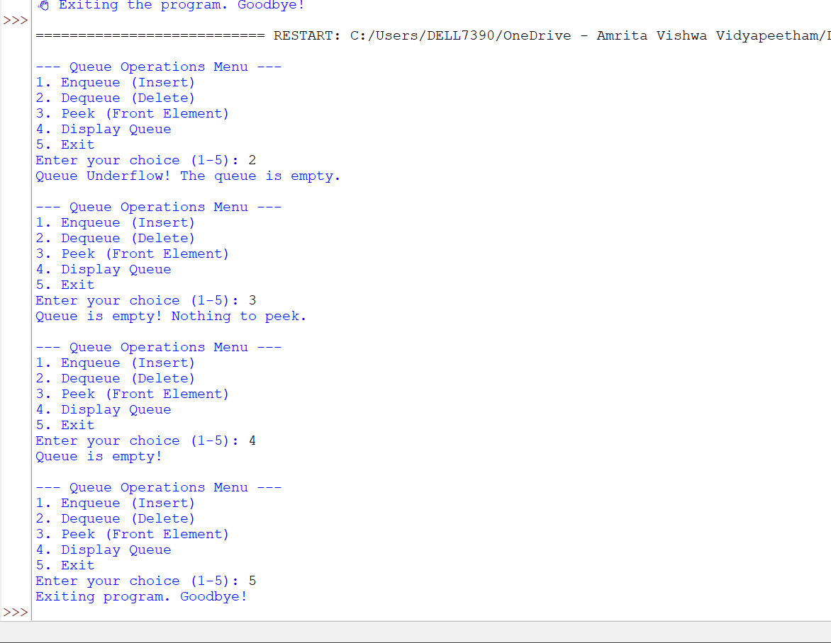

Explanation: A linked-list queue consists of dynamically created nodes. Each node contains two parts: Two pointers are maintained: Front: Points to the first node. Rear: Points to the last node.

ERROR TABLE:
1  After deleting the last node, rear may still point to the deleted node. | If front becomes None, set self.rear = None.
2  Displaying the linked list without moving to the next node can create an infinite loop. | Use current = current.next inside the display loop.

7C)
AIM: Write a Python program to implement a queue and its operations such as Enqueue, Dequeue, Peek, Display with a menu-driven approach. Implement using Circular Queue Arrays structures.
PROGRAM: 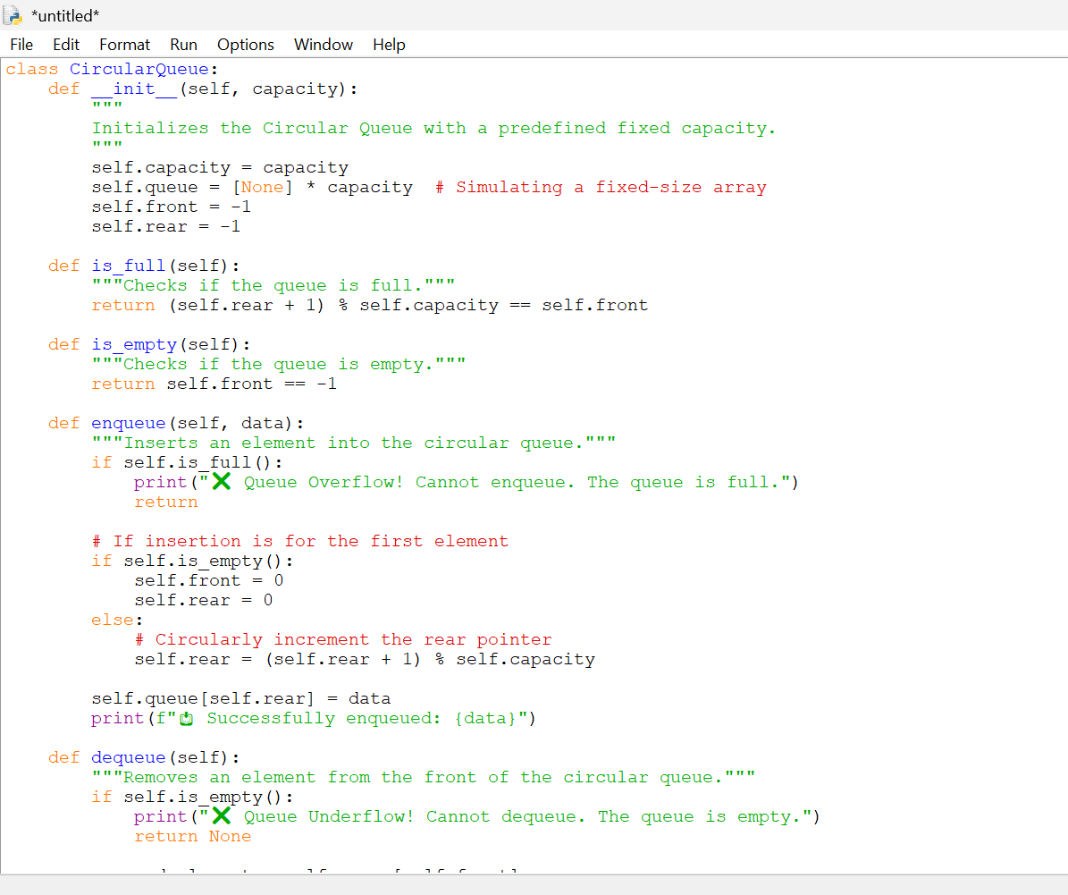

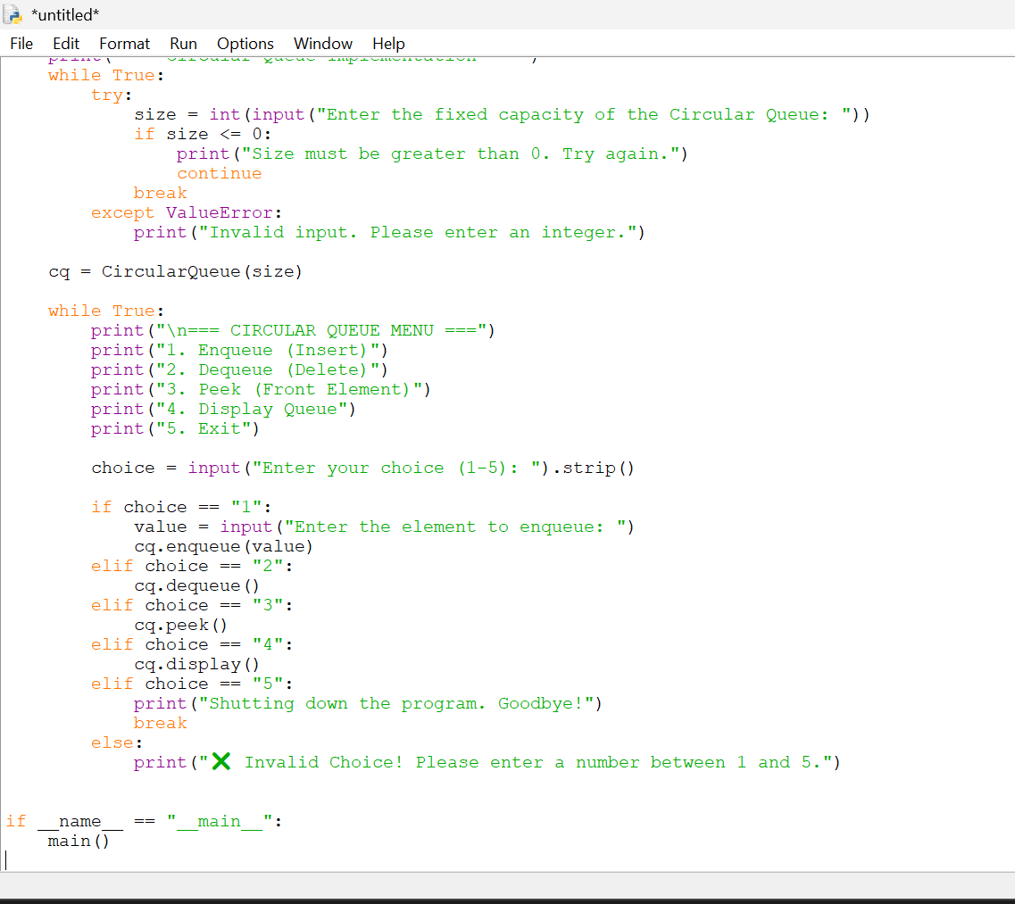
OUTPUT:
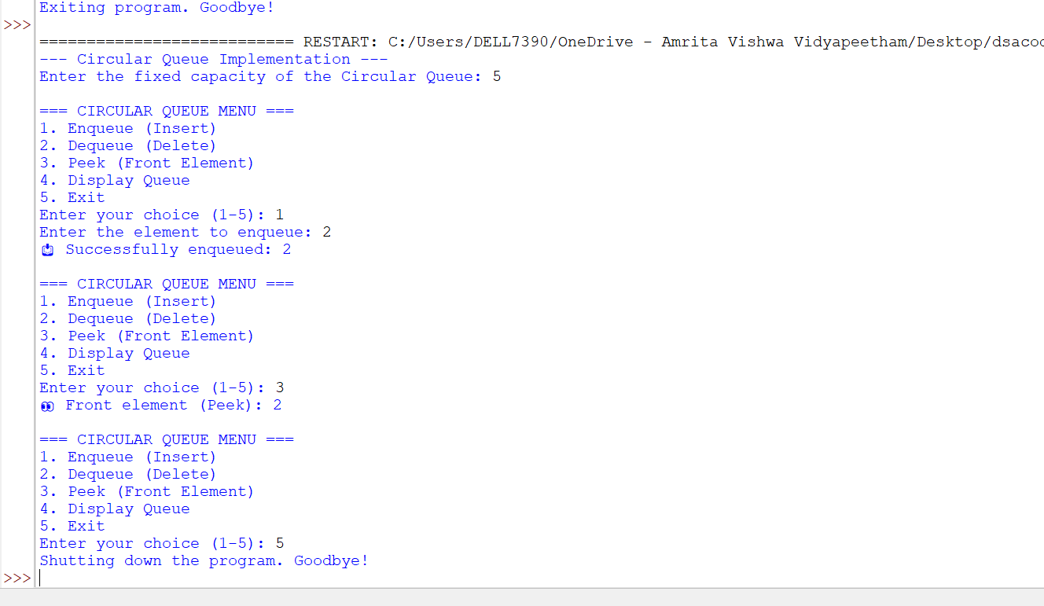

Explanation: A circular queue is a queue in which the last position is connected back to the first position. Unlike a normal linear queue, a circular queue can reuse empty positions created after dequeue operations.

ERROR TABLE:
Using rear + 1 without % MAX_SIZE can make the rear go outside the array. | Use rear = (rear + 1) % MAX_SIZE.
Not resetting both pointers after deleting the last element can leave the queue in an incorrect state. | When front == rear, set both front = -1 and rear = -1.

7D)
AIM:
Write a Python program to implement a queue and its operations such as Enqueue, Dequeue, Peek, Display with a menu-driven approach. Implement using Circular Queue linked-list data structures.
Program:
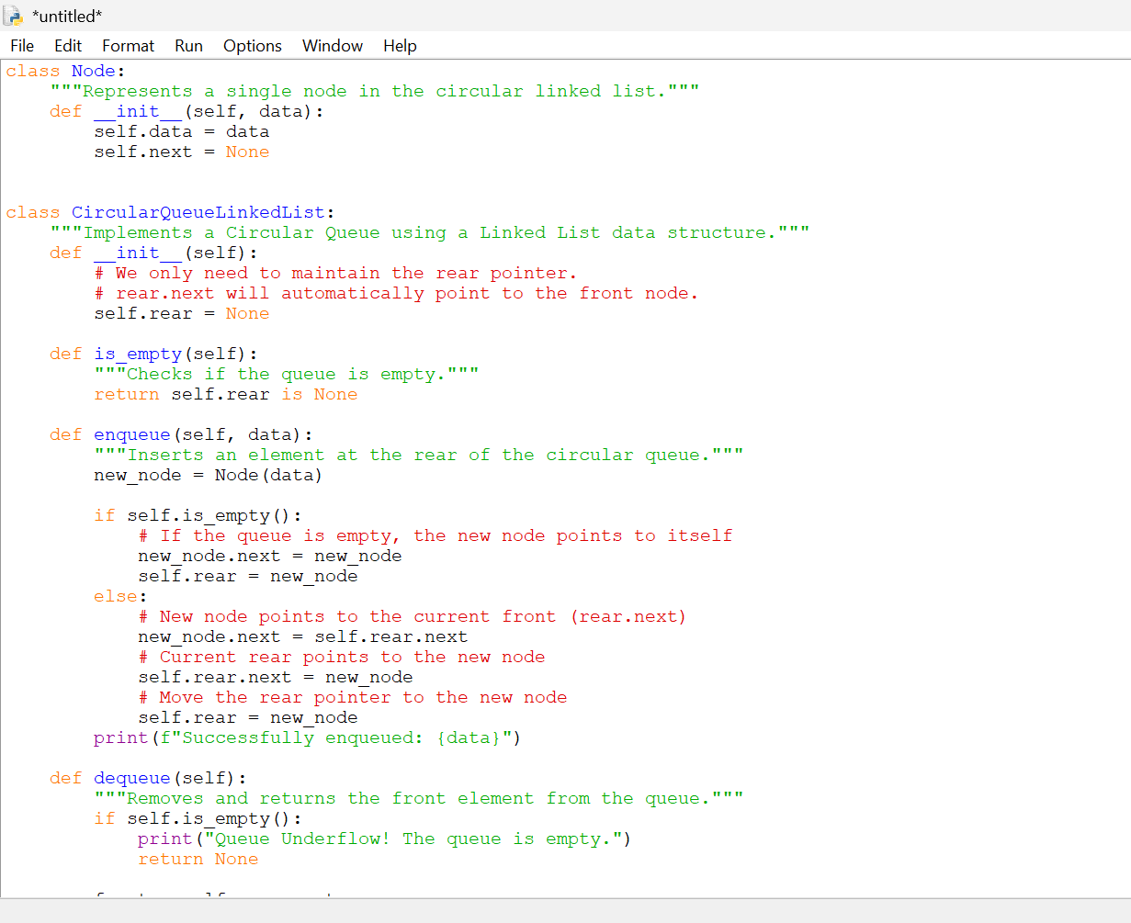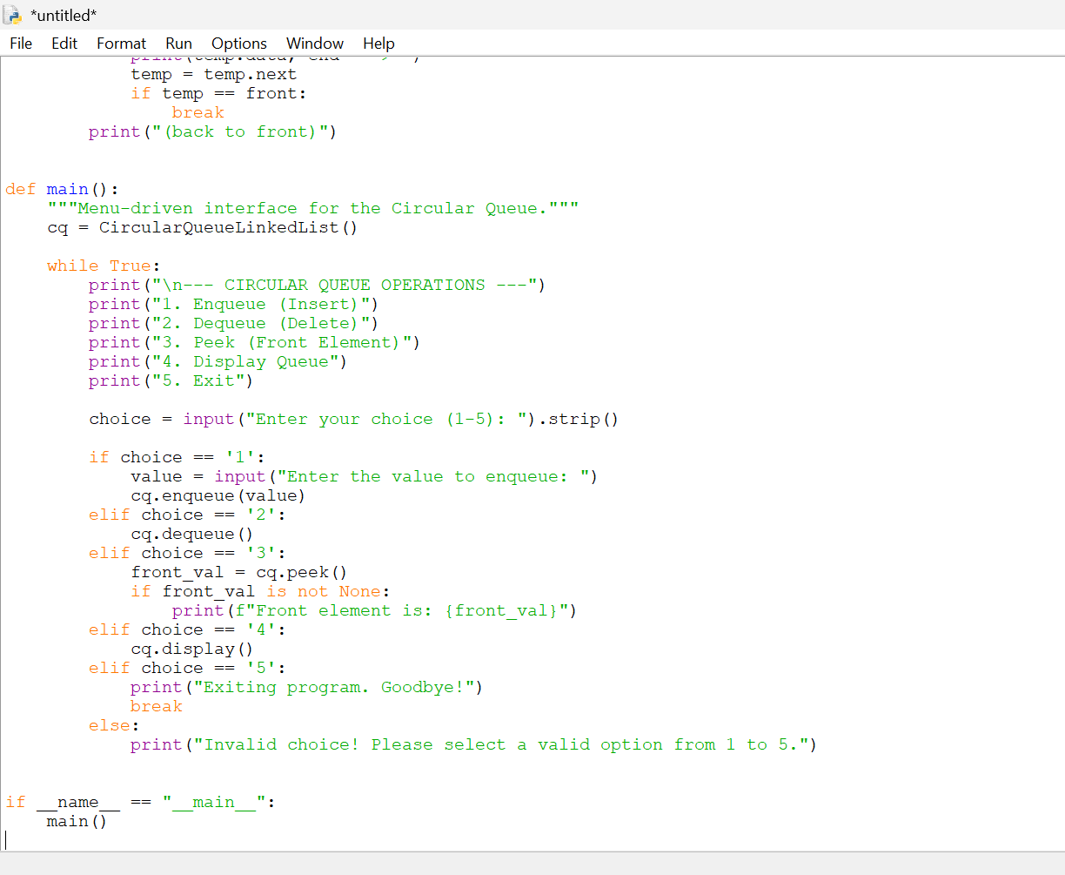

Output:
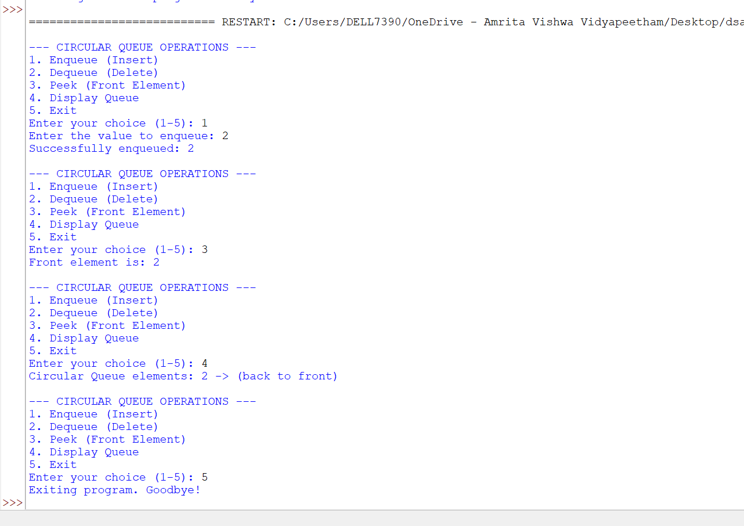

Explanation: data → stores the element. next → stores the address/reference of the next node. This inserts the new node at the rear while maintaining the circular connection.

Error table:
Setting rear.next = None breaks the circular connection. | Set rear.next = front so the last node points to the first node.
Not setting rear = None when the only node is deleted leaves an invalid queue. | If rear == front, set rear = None.

Lab-8:
a. ) Aim: write a python program to implement a binary tree with its operations using an array:
program: 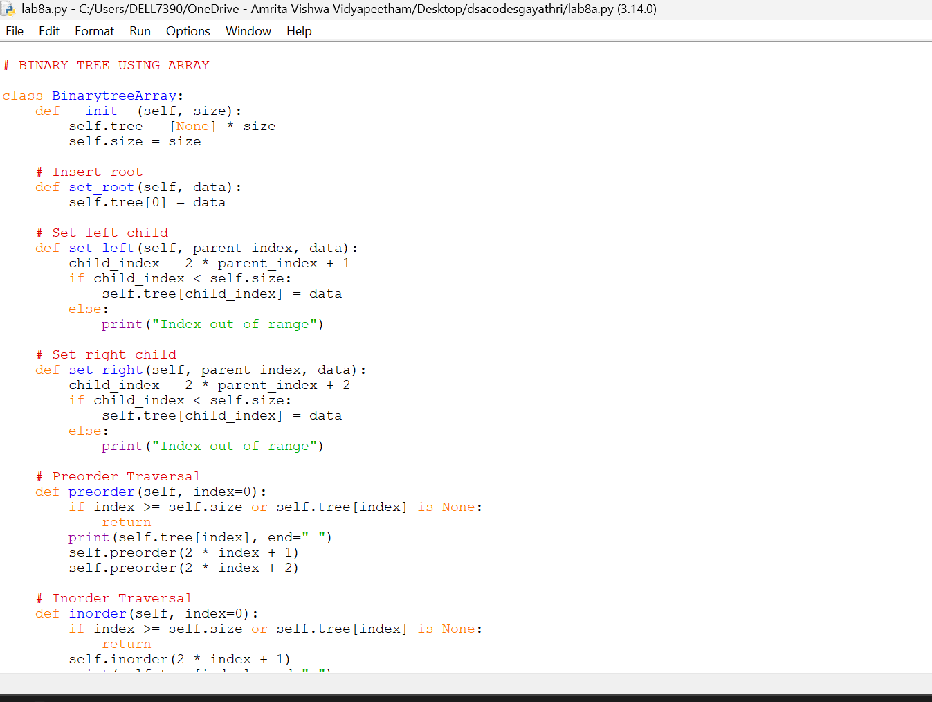

Output:
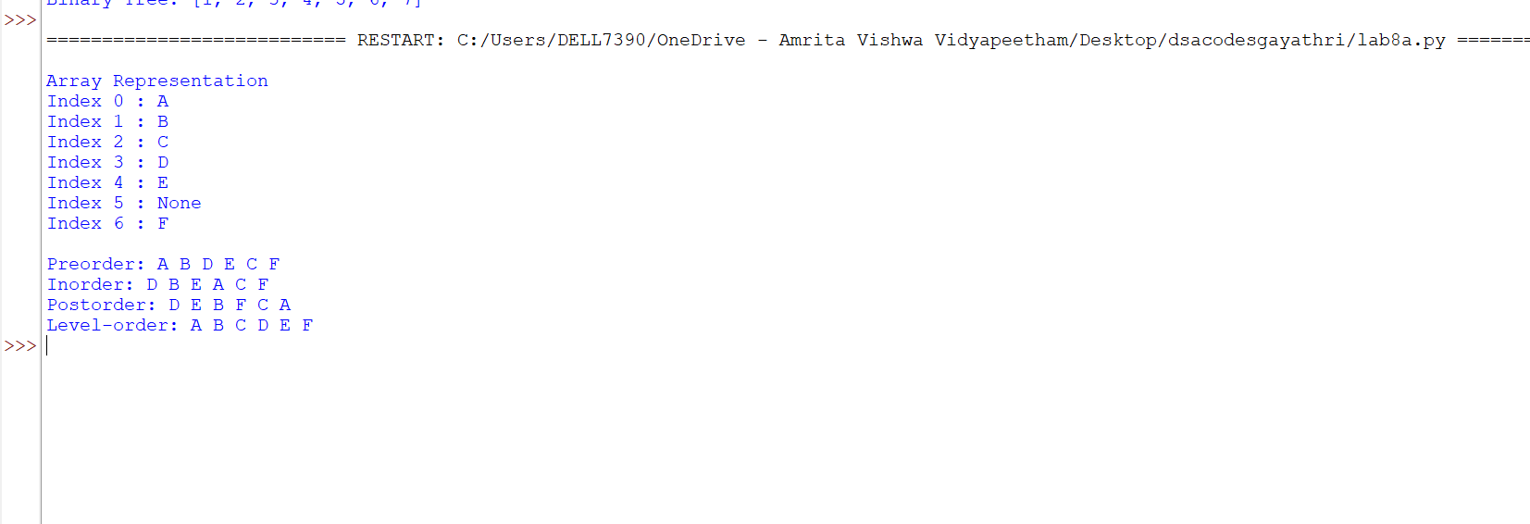

b) Aim: write a python program to implement a binary tree with its operations using Linked list:
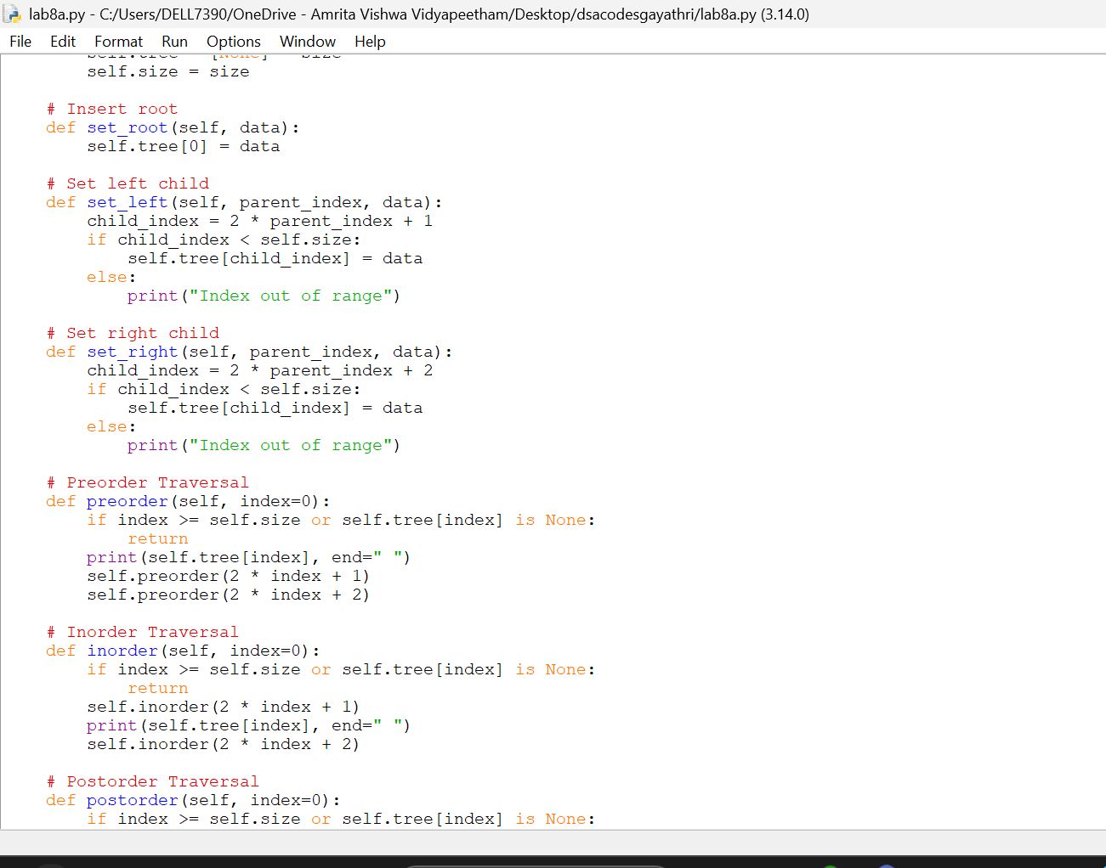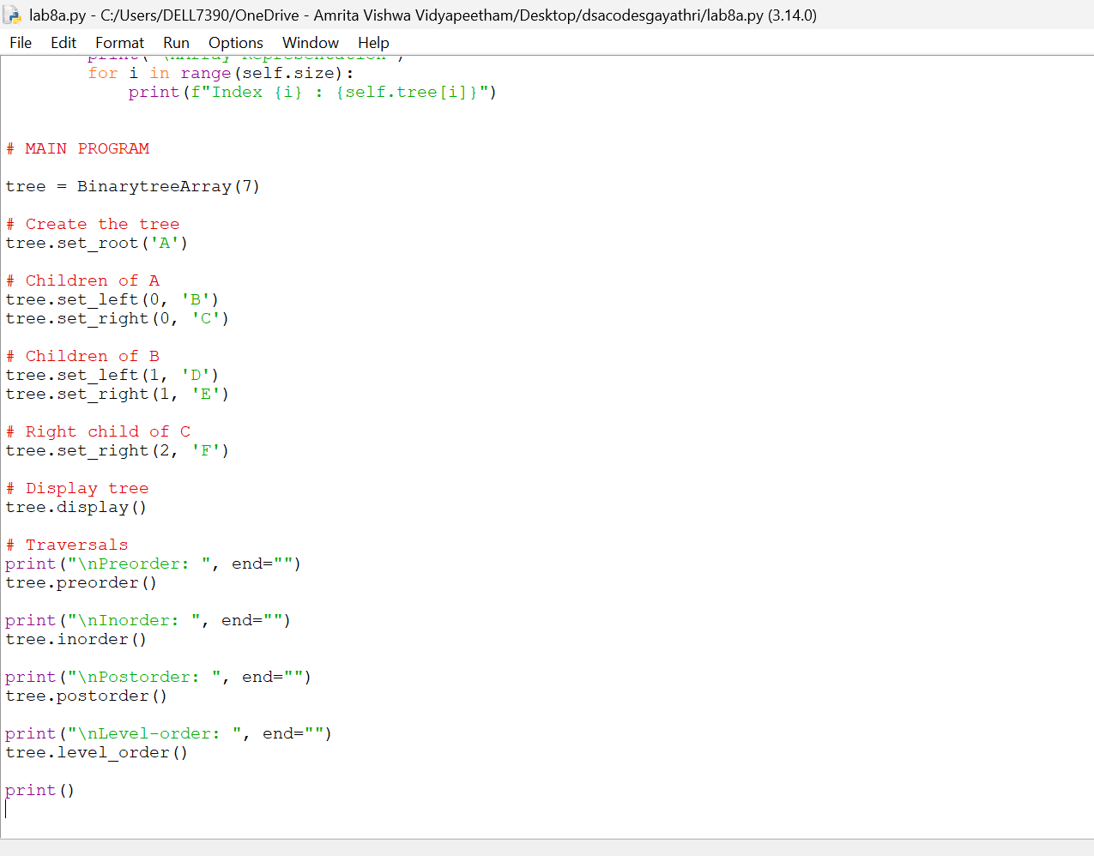
Output:

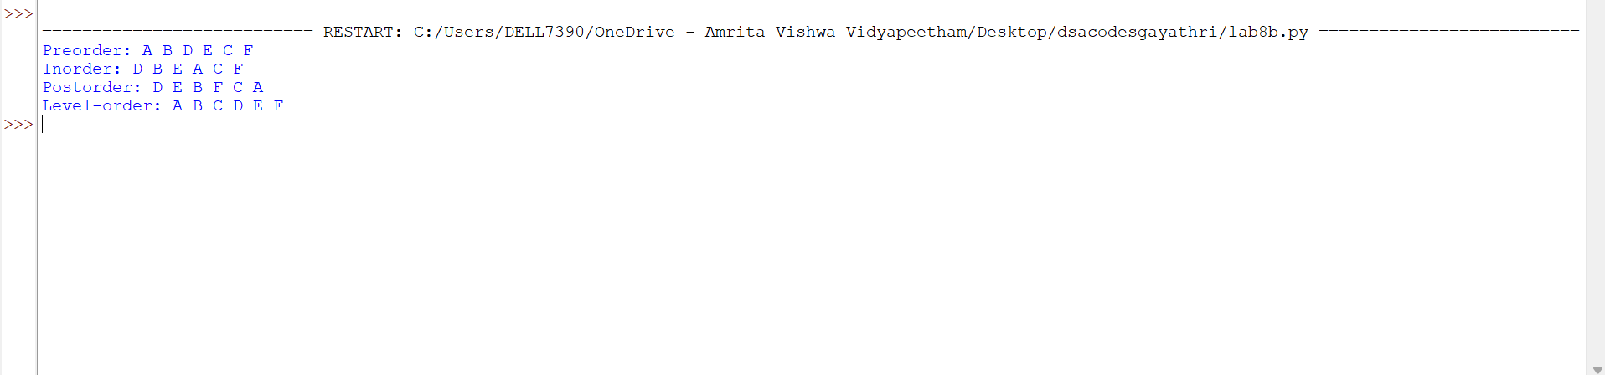
Lab-9:
- ) Aim: write a python program to implement a binary search tree with its operations and traversals:
Program : 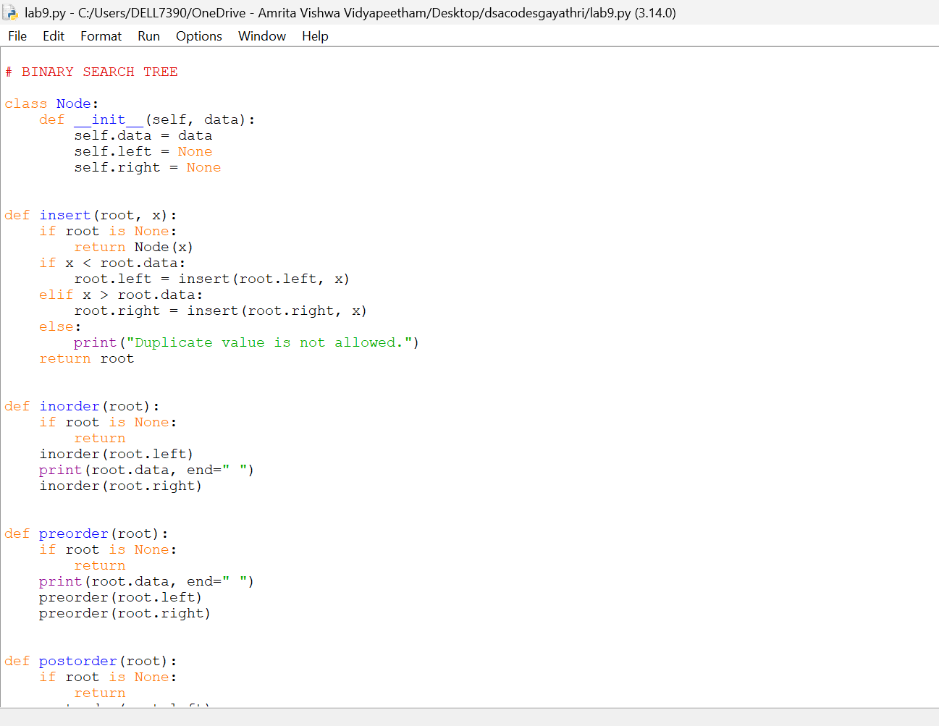
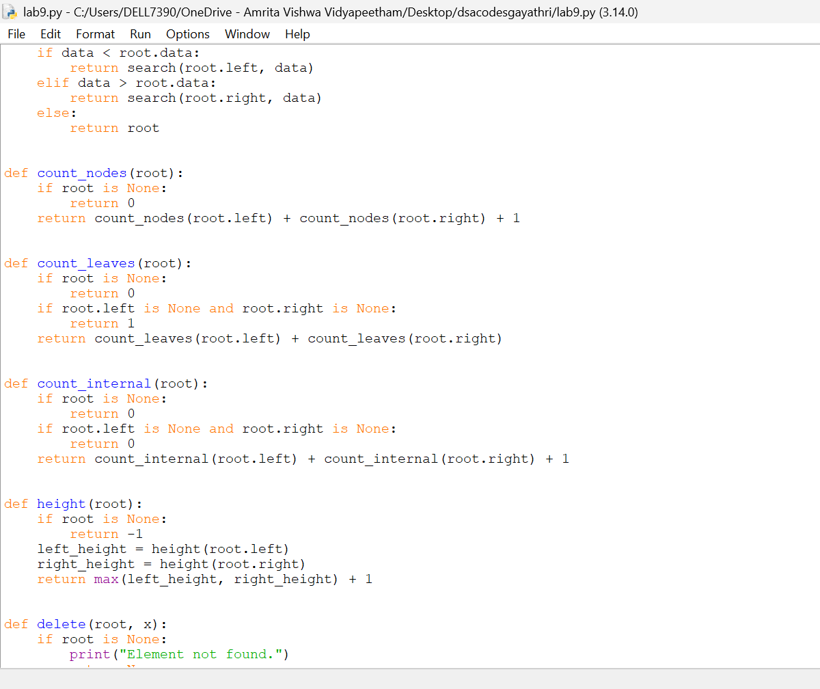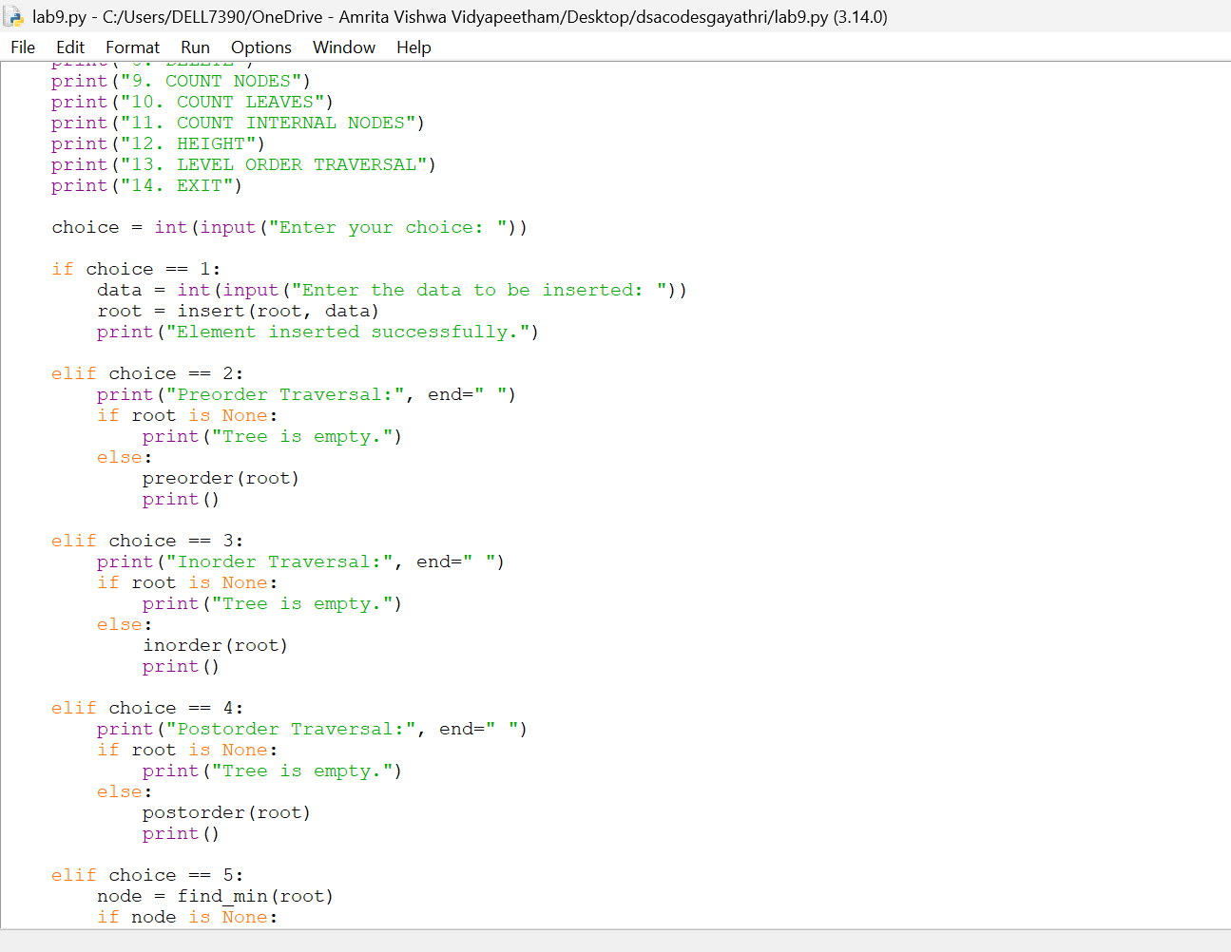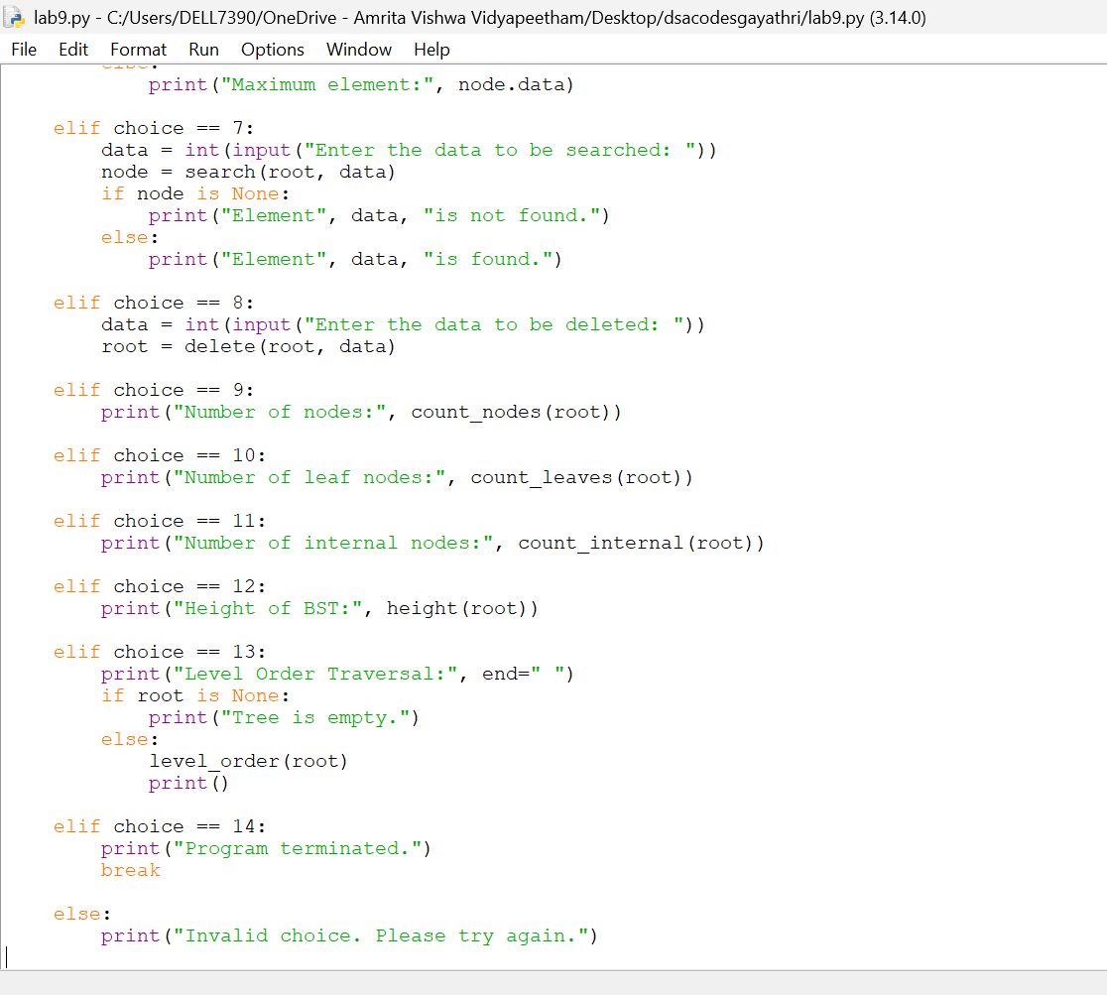

Output:



